
Indira Gandhi National Open University

Project Report on
iSchool (E-Learning Management System)

Submitted By:
Raj Kumar
Enr. No.- 13xxxxx81

Under Guidance of :
Mr. Kumar

Submitted to the School of Computer and Information Science, IGNOU
in partial fullfillment of the requirements for the award of the degree

Master of Computer Application (MCA)
(2018 – 2019)

Indira Gandhi National Open University
Maidan Garhi, New Delhi - 110068

Abstract
iSchool (E-Learning Management System) is a project which aims in developing an online application to provide Online Education, maintain Study Materials, keep Student records and collect Payments. This project has login features, Educator as Admin and Student as an user can login into their own portal separately. The Admin can login, through which the admin can monitor the whole system. This System can be used to search for course, add new courses, edit course, check payment status etc. The Admin after logging into his account can generate reports such as sell Report. The User can login into his account to follow course he purchased and can share his/her feedback.
Overall this project of ours is being developed to help the Educator (Admin) as well as Students (User) to provide Teaching-Learning platform in the best way possible.

Acknowledgment
It is a genuine pleasure to express my profound gratitude and deep regards to my guide "Mr. Kumar" for his exemplary guidance, monitoring and constant encouragement. I would like to express my special thanks to IGNOU who gave me the golden opportunity to do this wonderful project on the topic "iSchool (E-Learning Management System)", which helped me in doing a lot of research and i came to know about so many new things.

Table of Contents
Approved Proforma
Certificate of Originality
Abstract …………………………………………………………………………….……………………….…. i
Acknowledgement ………………………………………………………………………………………… ii
Table of Contents ……………………………………………………………….…………………….…… iii
Approved Synopsis ……………………………………………………………………………………….. vii
- Title of the Project ………………………………………………………………..……… vii
- Introduction ……………………..…………………………………………………..…….. viii
- Objectives ……………………………………………………………………………..…….. ix
- Project Category …………………………………………………………………..……… x
- Tools and Platform ………………………………………………………………..…….. xi
  - Hardware Requirements ………………………………………………… xi
  - Software Requirements …………………………………………………. xi
- Reason of using PHP and MySQL …………….………………………..………….. xii
  - PHP ………………………………………………………………….…………… xii
  - MySQL ………………………………….…………………………..…………… xii
- Data Flow Diagram …………………….………….…………………………………….. xiii
  - DFD 0 Level …………………………………………………………………… xiii
  - DFD 1 Level ………………………….………………………………………… xiv
- Entity Relationship Diagram (ER-Diagram) .…………….……………………. xv
- Flow Chart ……………..………………………………………………….………………. xvi
- Input/Output Modules of the Project …….…………………………………….. xvii
  - Input Modules …………………….………………………..…………… xvii
  - Output Modules ………………………………………………………… xvii
- Module and their Description ………………………………………………………. xviii
- Process Logic ……………………………………………………………………………… xx
- Data Dictionary …………………………………………………….…………………….. xxiv
- Limitation of the Project ……………………………………………………………… xxvii
- Future Scope of the Project …………………………………….…………………… xxviii
- Bibliography …………….……………………………………………………….………... xxix
List of Figures …………………………………………………………………………….………………….. xxx
Title of the Project Report .……………………………………………………………….……………... xxxi
Chapter 1: Introduction ……………………………………..………………………………..……………. 1
  - Overview ……………………………………………………………….…………. 1
  - Objectives ………………………………………………………………………… 2
Chapter 2: System Analysis …………………………………………………………..……………….. 4
2.1 Identification of Need …………………………………......………………….. 5
2.2 Software Requirements Specification (SRS) …………..…………….. 5
2.2.1 Data Gathering …………………………………………..……… 6
2.2.2 Feasibility Study ………………………………………..………. 7
2.2.3 Software Process Model …………………….……….………. 8
2.3 Data Flow Diagrams (DFD) …………………………..…………….………. 11
2.3.1 DFD 0 Level …………………………………………….……….. 11
2.3.2 DFD 1 Level ……………………………………………………… 12
2.3.3 DFD 2 Level ……………………………………………………… 13
2.4 Entity Relationship Diagram (ER-Diagram) ………………………….. 14
2.5 Flow Chart ………………………………………………………………………….. 15
2.6 Gantt Chart ……………………………………………………..….………………. 18 2.7 Class Diagram ………………………………………………..……………………. 19
Chapter 3: System Design …………………………………………………………………….……..…. 20
3.1 Input Module ………………………………………………………….…………. 20
3.2 Output Module …….……………………………………………………………. 21
3.3 Modularization Detail ………………………………………………………… 21
3.4 Process Logic …………………………………………………………………… 22
3.5 Data Integrity ………………………………………………….……………….. 26
3.6 Data Dictionary ……………………………………………..…………………... 27
3.7 User Interface Design ………………………………………………………… 33
Chapter 4: Tool and Environment …………………………………………………..……..……..… 34
4.1 Hardware Requirements ……………………………………..……………. 34
4.2 Software Requirements ……………………………………….….………… 34
Chapter 5: Software Description ……………………………………………….………………….... 35
5.1 PHP ………………………………………………………………………………… 35
5.2 MySQL ……………………………………………………………………………. 35
5.3 HTML ………………………………………………….…………….…….………. 36
5.4 CSS ………………………………………………………………………………… 36
5.5 JavaScript ………………………………………………………………………... 36
5.6 Bootstrap …………………………………………………….……….…….…… 37
5.7 Paypal Payment Gateway ………………………………….…….………… 37
5.8 Visual Studio Code …………………………………………………..……….. 37
5.9 yEd Graph Editor ………………………………………………………………. 38
5.10 StarUML …………………..…………………………………………..………… 38
Chapter 6: Program Code ………………………………………………………..……………………… 39
Chapter 7: Testing …………………………………………………………………………………………… 121
7.1 Type of Testing ……………………………………………….………………. 122
7.2 Use Case ……………………………………………………….………………… 124
7.3 Test Cases ……………………………………………………………..………… 127
Chapter 8: Implementation …………………………………………………..………………………… 129

Chapter 9: Cost Estimation of Project ………………………………………….………………..…. 130
9.1 Domain and Hosting Cost ………………………………………..……………. 130
9.2 Hardware Cost …………………………………………………………………… 130
9.3 Software Cost …………………………………………………….……………….. 131
9.4 Development Cost/ Operating Cost ………………………..…………….. 131

Chapter 10: Limitations ………………………………………………………………………………….... 132
Chapter 11: Future Scope …………………………………………………………….…………………… 133
Chapter 12: Conclusion ..…………………………………………………………………………………… 134
Bibliography …………………………………………………………………………..…………………………. A

Approved Synopsis
- Title of the Project



(E-Learning Management System)

- Introduction
It is difficult to find time for the training necessary to gain new skills and boost your productivity. With iSchool you’re able to learn at a pace that is comfortable for you. iSchool is a powerful Learning Management System implementing the latest trends in e-learning. E-Learning is learning utilizing electronic technologies to access educational curriculum outside of a traditional classroom. In most cases, it refers to a course, or program delivered completely online. We define eLearning as courses that are specifically delivered via the internet to somewhere other than the classroom where the professor is teaching. E-Learning has been proven to be a successful method of training and education is becoming a way of life for many citizens in India and across the World. iSchool Publisher is a professional team development environment for the rapid development of e-courses by their own.
Any Person who wants to gain new skills can join iSchool. A Person/Student/Learner has to fill up registration form which is absolutely Free. Once Learner registers successfully, they will get UserID/Email and Password for login into Student/Learner Panel. After login they can buy any course as per their choice or requirement which is available in iSchool. They can watch purchased video courses online and can submit their feedback. As well they can update their profile and can change password. Admin of this system will upload new courses which will be available for everyone. Admin can delete or edit student/learner details. Admin can modify course details and can check sells report.

- Objectives
A flexible web-based learning experience allows you to go through a guided curriculum or choose lessons on an as-needed basis. Following are the main objectives:-
- Ability to recall previously learned material – Students/learners can watch video courses as many times as they need. If they forgot something during the course they can come back and watch that specific part anytime.
- Creative way to present lesson – It is very creative way to present lectures. It will surely enhance teaching ability of tutor.
- Low Cost – As nobody needs to travel or rent anything so it’s very cost efficient.
- High Quality – As tutor do not has time boundation so he can teach in his own comfort time.
- Learn anytime from anywhere – Students/Learners can start learning anytime from anywhere they just required internet connection with a compatible device.
- Improve course quality according to learner’s feedback – Tutor can improve their course as per student’s feedback. It will help tutor to improve their ability to teach.
- Earn Money Online– As courses are paid so we can say it’s an online teaching business which has no boundaries means students/learners can join from across the world so this system can make good business with good quality.

- Project Category

This project as titled “iSchool (E-Learning Management System)” is comes under the Web Based Application. This application is developed with the help of HTML, CSS, Bootstrap, PHP, MySQL etc.
Web Based Application

- Tools/Platform
5.1 Hardware Requirements

Processor | 1.6 GHz or Faster Processor
RAM | 4 GB
Disk Space | 10 GB of Available Hard Disk
Graphic | DirectX 9-Capable Video Card
Display | 1024 X 768 or Higher Resolution

5.2 Software Requirement
Operating System | Windows 10
Front End | HTML, CSS, JavaScript
Back End | PHP
Library/ Framework | Bootstrap, JQuery, FontAwesome
Plugins | Owl Carousel
Code Editor | Visual Studio Code 1.33
Database | MySQL
Web Server | Apache
Web Browser | Google Chrome
Payment Gateway | Paypal
Drawing Tools | yEd Graph Editor
Drawing Tools | StarUML

- Reason of using PHP and MySQL
6.1 PHP
PHP is an open source language and all its components are free to use and distribute. PHP is server-side scripting language. It is embedded in HTML source code. PHP supports all major web servers such as Apache, Microsoft IIS and Netscape etc. All the major database such as Mysql, PostgreSQL, Oracle, Sybase, Microsoft SQL Server is supported by PHP. Following are the some major advantage:-
- Friendly With HTML - PHP and HTML are interchangeable within the page. You can put PHP outside the HTML or inside.
- Interactive Features - PHP allows you to interact with your visitors in ways HTML alone can't.
- Top-Notch Online Documentation - The PHP documentation is the best on the web. Hands down.
- Compatible With Databases - A good benefit of using PHP is that it can interact with many different database languages including MySQL.
6.2 MySQL
MySQL is the most popular open source relational database management system. It is one of the best RDBMS being used to develop web-based applications. It is easy to use and fast RDBMS. Following are the top reason to use MySQL:-
- High Performance
- Robust Transactional Support
- Strong Data Protection
- Open Source Freedom
- Data Flow Diagram
Data flow diagram is graphical representation of flow of data in an information system. It uses defined symbols like rectangles, circles and arrows, plus short text labels, to show data inputs, outputs, storage points and the routes between each destination.

7.1 DFD 0 Level
The 0 Level DFD shows flow of data of application. DFD Level 0 is also called a Context Diagram. It’s a basic overview of the whole system or process being analyzed or modeled.
Buy Course
Upload Course
Student/Learner
Admin
iSchool
(E-Learning Managment System)
Report
Watch Course
O Level DFD

7.2 DFD 1 Level
DFD Level 1 provides a more detailed breakout of pieces of the Context Level Diagram. This DFD describes main functions carried out by the system, as we break down the high-level process of the Context Diagram into its sub-processes.
1 Level DFD
retrieve
Authentic Status
feedback
update
submit
update
update
view
retrieve
retrieve
retrieve
update
lesson
course
student
Admin/Student
Update profile
Update lesson
Upload course
Logout
Admin
Authentic
Authentic Status
Authentic Status
Authentic Status
Authentic Status
feedback
Student
Sell course
Authentic Status
courseorder
Report
Watch course

- Entity Relationship Diagram (ER-Diagram)
An Entity Relationship Diagram (ERD) is a visual representation of different entities within a system and how they relate to each other.

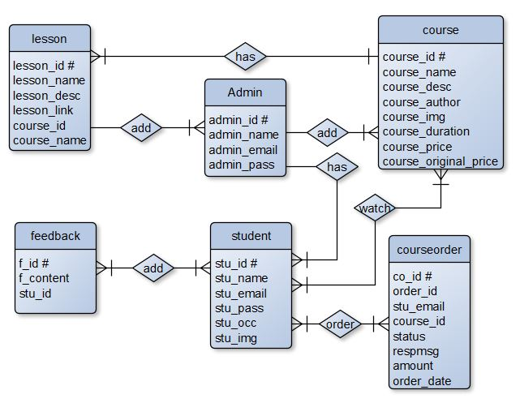

ERD

- Flow Chart
A flowchart is a diagram that depicts a process, system or computer algorithm. They are widely used in multiple fields to document, study, plan, improve and communicate often complex processes in clear, easy-to-understand diagrams.
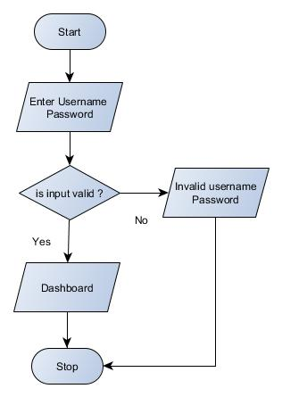
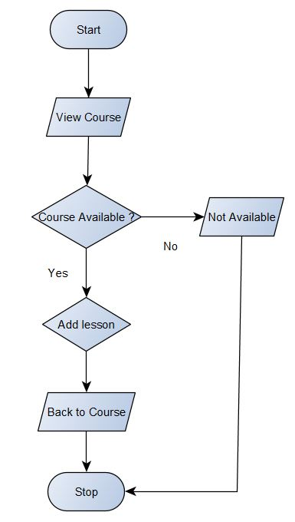
Add Lesson
Login

- Input/ Output Modules of the Project
10.1 Input Modules
- Student/Learner Registration
- Course
- Lesson
- Feedback
- Payment Status

10.2 Output Modules
- Student/Learner List
- Course Detail
- Lesson Detail
- Sell Report
- Payment Receipt

- Modules and Their Description
Without Registration
Home – This module contains all the links of the application such as Courses, Payment Status, Login, Sign Up, Feedback Section and Contact.
Courses – This module contains list of all the courses which are available at iSchool.
Payment Status – This module is used to check Payment status after purchasing a course.
Login – This module is used to login into Student/Learner Panel.
Sign Up – This module is used to register for the Student/Learner Panel.
Feedback – This section shows feedback given by registered students/learners.
Contact – Learner can use this section to contact the admin/tutor for any kind of queries.
Student Panel
Profile – This module contains all the details about Student/Learner as well as Student can update their details.
My Courses – This module contains list of all purchased courses.
Feedback – This module is used to write feedback.
Change Password – Students can use this module to change password.
Logout – This module is used to return back to Home Page.
Admin Panel
Dashboard – This module displays overview of whole application.
Courses – This module contains all the courses.
Lessons – This module contains all the lesson depends on course id.
Students – This module displays all the registered student details.
Sell Report – This module is used to view and print sells report.
Payment Status – This module displays payment status in more details.
Feedback – This module displays feedback given by students.
Change Password – Admin can use this module to change password.
Logout – This module is used to return back to Home Page.

- Process Logic
Home:
When the user click on this tab, it will display the other modules and pages of the website such as courses, payment status, login, sign up, popular section, feedback section, contact and admin login. This module will be used to display the brief introduction of the project and will show the title of the project.
Courses:
Student can view all available courses by clicking on courses tab where he can choose course according to his own interest and by clicking on a particular course, will display more details with lesson title of the course, if he wants to purchase he will be able to make payment (required login).
Payment Status:
After purchasing course student will be provided an order id which can be used to get the status of payment using Payment status tab. If student wants he can get print out of his payment status.
Login:
This is a login form. Student/Learner can use their own email and password to login into the student panel.
Sign Up:
This is a Registration form for new Students/Learners. New Students/Learners can fill up the form for registration and after successful registration they can use their email id and password to login into the application.
Feedback:
This is very simple section which displays feedback given by the registered student.
Contact:
Learner can use this section to contact the admin/tutor for any kind of queries.
Student Panel:-
Profile:
Students/Learners can view their student id, registered email id, name, occupation, profile picture as well as they can modify and update the new data if they need.
My Courses:
Students can view all courses which they purchased. This is the place where they can start watching lectures by clicking on Watch Course button which leads to course playlist where they can watch the entire lesson of course.
Feedback:
Students can view/write feedback.
Change Password:
Students can use this module to change password.
Logout:
This module is used exit student panel and return back to Home Page.

Admin Panel
Dashboard:
This module displays overview of whole application such as number of course, number of registered students etc.
Courses:
This is the most important module of admin panel where Admin can view list of course as well as add new courses and modify or delete courses.
Lessons:
Admin can view lesson based on course id as well as new lesson can be added to the course and modification or deletion is also possible using this module.
Students:
Admin can view registered students details. Admin can add, edit and delete student.
Feedback:
Admin can view/delete feedback given by student.
Sell Report:
Analyzing sales is very import for any kind of business and this module is perfect for analyzing sales based on date. It will generate sells report which can be possible to print out for office records.

Payment Status:
If student file any complaints regarding payment Admin can use this module to display payment status in more details such as bank name, transaction id, payment date etc.
Change Password:
Admin can use change password.
Logout:
This module is used exit admin panel and return back to Home Page.

- Data Dictionary
In order to maintain the data of the database a number of tables are used. Various tables contain data about the various entities.
Table Name: Admin (Stores Admin Detail)
Attribute | Data Type | Description
admin_id # | int(11) | Stores Admin ID
admin_name | varchar(255) | Stores Admin Name
admin_email | varchar(255) | Stores Admin Email ID
admin_pass | varchar(255) | Stores Admin Password

Table Name: Student (Stores Student Detail)
Attribute | Data Type | Description
stu_id # | int(11) | Stores student ID
stu_name | varchar(255) | Stores student Name
stu_email | varchar(255) | Stores student Email ID
stu_pass | varchar(255) | Stores student Password
stu_occ | varchar(255) | Stores student occupation
stu_img | text | Stores student profile picture

Table Name: Feedback (Stores Feedback Detail)
Attribute | Data Type | Description
f_id # | int(11) | Stores Feedback ID
f_content | text | Stores Feedback content
stu_id | int(11) | Stores Student ID

Table Name: course (Stores Course Detail)
Attribute | Data Type | Description
course_id # | int(11) | Stores Course ID
course_name | text | Stores course Name
course_desc | text | Stores course description
course_author | varchar(255) | Stores course author/instructor
course_img | text | Stores course display picture
course_duration | text | Stores course duration
course_price | int(11) | Stores course selling price
course_original_price | int(11) | Stores course original price

Table Name: Lesson (Stores Lesson Detail)
Attribute | Data Type | Description
lesson_id # | int(11) | Stores Lesson ID
lesson_name | text | Stores Lesson name
lesson_desc | text | Stores lesson description
lesson_link | text | Stores lesson video link/video file
course_id | int(11) | Stores course ID
course_name | text | Stores course Name

Table Name: courseorder (Stores Course order Detail)
Attribute | Data Type | Description
co_id # | int(11) | Stores course order ID
order_id | varchar(255) | Stores Order ID (Random)
stu_email | varchar(255) | Stores student email id
course_id | int(11) | Stores course id
Status | varchar(255) | Stores payment status
Respmsg | text | Stores payment response msg
Amount | int(11) | Stores course amount
order_date | date | Stores purchase date

- Limitations of the Project
- Only one tutor can access at a time
- It’s not SEO friendly
- Risk unauthorized accessibility
- Support is good in modern web browsers but not in legacy ones

- Future Scope of the Project
- More than one tutor can be added
- Interaction between Student and Tutor can be improved by introducing Discussion forum
- Quiz Facility may enhance this application’s market value
- Live Class can be added

- Bibliography
Books: -
- IGNOU Blocks of Systems Analysis and Design
- IGNOU Blocks of Introduction to Software Engineering
- The Complete Reference PHP
- Head First SQL: Your Brain on SQL by Lynn Beighley
Web Source: -
- www.google.co.in
- www.wikipedia.org
- www.php.net
- www.stackoverflow.com
- www.getbootstrap.com

List of Figures

Page No.
Figure 1: DFD 0 Level ………………………………………………………………………………. 11
Figure 2: DFD 1 Level ………………………………………………………………………………. 12
Figure 3: DFD 2 Level ………………………………………………………………………………. 13
Figure 4: ER – Diagram ……………………………………………………………………………. 14
Figure 5: Flow Chart ………………………………………………………………………..………. 15
Figure 6: Gantt Chart …………………………………………………………………………….…. 18
Figure 7: Class Diagram ……………………………………………………………………………. 19
Figure 8: Use Case …………………………………………………………………………………… 126

Project Report on

(E-Learning Management System)

- Introduction


The use of e-Learning technology in higher education institutions is no longer an option but has become a necessity. In an era known as the society of technology and knowledge, where lifelong learning is a way of life, it is important that educational institutions have as a priority the goal of finding effective ways of providing new learning opportunities according to their environment, student characteristics, teacher training, economic crisis and advancing technology in an effort to make learning more efficient, equitable and innovative in higher education.
Normally it has been practised in higher education and corporate and occupational training contexts as a part of lifelong learning. However, with the emergence of new open and mobile platforms and web apps, a range of possibilities has opened to facilitate teaching and learning processes in fully on-site or blended environments. As a result, e-learning has been implemented in all educational systems, transcending the traditional idea of distance education.

  - Overview

It is difficult to find time for the training necessary to gain new skills and boost your productivity. With iSchool you’re able to learn at a pace that is comfortable for you. iSchool is a powerful Learning Management System implementing the latest trends in e-learning. E-Learning is learning utilizing electronic technologies to access educational curriculum outside of a traditional classroom. In most cases, it refers to a course, or program delivered completely online. We define eLearning as courses that are specifically delivered via the internet to somewhere other than the classroom where the professor is teaching. E-Learning has been proven to be a successful method of training and education is becoming a way of life for many citizens in India and across the World. iSchool Publisher is a professional team development environment for the rapid development of e-courses by their own.
Any Person who wants to gain new skills can join iSchool. A Person/Student/Learner has to fill up registration form which is absolutely Free. Once Learner registers successfully, they will get UserID/Email and Password for login into Student/Learner Panel. After login they can buy any course as per their choice or requirement which is available in iSchool. They can watch purchased video courses online and can submit their feedback. As well they can update their profile and can change password. Admin of this system will upload new courses which will be available for everyone. Admin can delete or edit student/learner details. Admin can modify course details and can check sells report.

  - Objectives

A flexible web-based learning experience allows you to go through a guided curriculum or choose lessons on an as-needed basis. Following are the main objectives:-
- Ability to recall previously learned material – Students/learners can watch video courses as many times as they need. If they forgot something during the course they can come back and watch that specific part anytime.
- Creative way to present lesson – It is very creative way to present lectures. It will surely enhance teaching ability of tutor.
- Low Cost – As nobody needs to travel or rent anything so it’s very cost efficient.
- High Quality – As tutor do not has time boundation so he can teach in his own comfort time.
- Learn anytime from anywhere – Students/Learners can start learning anytime from anywhere they just required internet connection with a compatible device.
- Improve course quality according to learner’s feedback – Tutor can improve their course as per student’s feedback. It will help tutor to improve their ability to teach.
- Earn Money Online– As courses are paid so we can say it’s an online teaching business which has no boundaries means students/learners can join from across the world so this system can make good business with good quality.
- System Analysis

System Analysis is the process of studying a procedure in order to identify its goals and purposes and create systems and procedures that will achieve them in an efficient way. It is a problem solving technique that improves the system and ensures that all the components of the system work efficiently to accomplish their purpose.
A systems analyst researches problem, plans solutions, recommends software and systems, and coordinates development to meet business or other requirements. The main goal of this system analyst is to collect different data from different site, process these data and generate progress as well as daily report.
System analyst operates in a dynamic environment where change is a way of life. The environment may be a business firm, a business application, or a computer system. to construct a system the following key elements must be considered: -
Input: Input is what data the system receives to produce a certain output.
Output: What goes out from the system after being processed is known as Output.
Processing: The process involved to transform input into output is known as Processing.
Control: In order to get the desired results it is essential to monitor and control the input, Processing and the output of the system. This job is done by the control.
Feedback: The Output is checked with the desired standards of the output set and the necessary steps are taken for achieving the output as per the standards, this process is called as Feedback. It helps to achieve a much better control in the system.
Boundaries: The boundaries are nothing but the limit of the system. Setting up boundaries helps for better concentration of the actives carried in the system.
Environment: The things outside the boundary of the system are known as environment. Change in the environment affects the working of the system.
Interfaces: The interconnections and the interactions between the sub-systems are known as the Interfaces. They may be inputs and outputs of the systems.

2.1 Identification of Need

The old manual system was suffering from a series of drawbacks. Since whole of the system was to be maintained offline at one place only, the ease of service was not there. The information (lectures) was never used to be in a systematic order. It was not possible to provide service for large community from different places at the same time. It was seriously affecting the business. For this reason we have provided features present system is automated the whole procedure. Present system can be spread to the world so it would be beneficial for the business.

2.2 Software Requirements Specification (SRS)

A software requirements specification is a document that captures complete description about how the system is expected to perform. It is usually signed off at the end of requirements engineering phase.

Product perspective
The software product is a Web Application. The application will be made up of two parts, one administrator who has all the rights and the other user who has limited rights to handle the application. The two users of the system, namely the Teacher/Educator (Admin) and Student/Learner (User) interact with the system in different ways.

Product Functions
First of all it will authenticate the user whether he is Educator (Admin) or Learner (User) the unauthorized person can’t get access to the application.
The Admin will be able to Add, delete, and modify Student Details. He can also Add, delete and modify Course and Lesson Details. He can use this application to check report related to sells as well as he can check Payment Status.
The User can edit his own profile and upload his profile picture. He will be able to purchase courses published by admin. User can use application to watch purchased course’s lessons. User can write feedback. Feedback will help Admin to improve the quality of content or service.

Safety Requirements
All the data will be saved to database for safety purpose so there will be no data loss. These data can be accessed only by an authorized person so data theft is also not possible in this application.

Security Requirements
For preventing unauthorized access to the application, this application have login feature so only granted user can access with defined rights.

2.2.1 Data Gathering
Data collection is the systematic approach to gathering and measuring information from a variety of sources to get a complete and accurate picture of an area of interest. Data collection enables a person or organization to answer relevant questions, evaluate outcomes and make predictions about future probabilities and trends. Accurate data collection is essential to maintaining the integrity of research, making informed business decisions and ensuring quality assurance.

2.2.2 Feasibility study

Feasibility study means to check whether the project is feasible or not, that means possible or not. Some feasibility study regarding this project is as follows: -

Economic Feasibility
The project has shown the economic feasibility by the study of the fact that by using this software the increased number of the users can be given service effectively and efficiently and can save a lot time and saving time means saving money. The cost and benefit analysis has shown that cost that have incurred in developing the project is less than the benefits that the project is going to provide once it is developed, so this project has passed the feasibility test.

Technical Feasibility
Technical feasibility centers on the existing computer system (Hardware, Software etc.) and to what extent it supports the existing system. As the existing system computer system is viable so there is no matter of technical feasibility that is the system is technically feasible. In this type of feasibility study it is checked whether there is a need of new hardware/software or not. What are the basic requirements of the project? If there is need then how it can be fulfilled. In this context, this project doesn’t need any special hardware or software. It can run on window 7/10 platform. However, Internet and a Web browser is needed to run the web application.

Behavioral Feasibility
The Users are also interested in this project, as it will help them to do work with ease and efficiently without complexity, so they supported the development of this project with full enthusiasm. This shows the behavioral feasibility of the project.

Time Feasibility
It is the determination of whether a proposed project can be implemented fully within stipulated time frame. The project was decided to be done in three months and was thought to be feasible.

Operational Feasibility
In this feasibility study it is determined whether there is need of well qualified operator or simple user. Is there need to train the operator or not? This project is supporting the User friendly Web application; hence operating this project is so simple. Even a person who has a little knowledge of computer can easily handle this well. There is no need of trained operator.

2.2.3 Software Process model

The Software Process Models are the various processes or methodologies that are being selected for the development of the project depending on the project’s aims and goals. There are many development life cycle models that have been developed in order to achieve different required objectives. The models specify the various stages of the process and the order in which they are carried out.
The selection of model has very high impact on the testing that is carried out. It will define the what, where and when of our planned testing, influence regression testing and largely determines which test techniques to use.
Choosing right model for developing of the software product or application is very important. Based on the model the development and testing processes are carried out.
A Process Model describes the sequence of phases for the entire lifetime of a product. Therefore it is sometimes also called Software Life Cycle. This covers everything from the initial commercial idea until the final de-installation or disassembling of the product after its use.

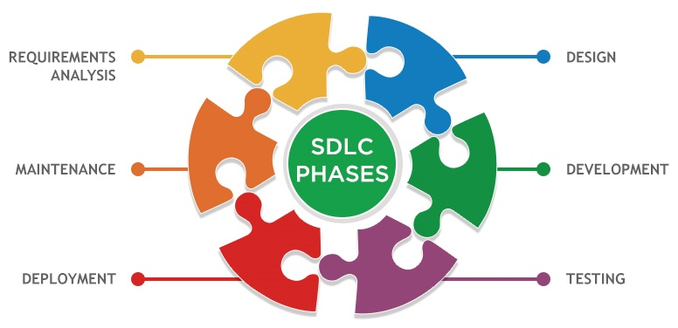

In order to develop the project “iSchool” we have adopted the Iterative Enhancement Model also known as Incremental Model. This model removes the shortcoming of waterfall model. Since many facts of this system are already known. It is not a new concept and hence no research is required. A working version can be easily created and hence the system can start working. Rest of the functionalities can be implemented in the next iteration and can be delivered later. As the requirement analysis is also not required. It not being a new technology risk involved is also less. So one need not perform detailed risk analysis. If redevelopment staff is less than development can be started with less number of people and in next increments others can be involved. As this model combines the advantage of waterfall model and prototyping, clients are always aware of the product being delivered and can always suggest changes and enhancements and can get them implemented. As less amount of customer communication is required one need not apply spiral model in which all types of analysis is done in detail. As the deadline is affordable one need not to for Rapid Application Development model. Iterative enhancement model is useful when less manpower is available for software development and the release deadlines are specified. It is best suited for in house product development, where it is ensured that the user has something to start with. The complete product is divided into releases and the developer delivers the product release by release.

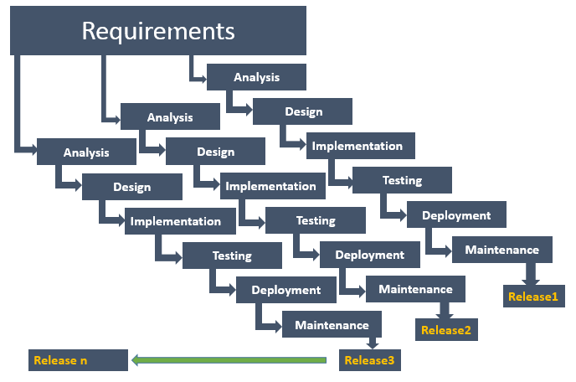
Incremental Model
2.3 Data Flow Diagram (DFD)

Data flow diagram is graphical representation of flow of data in an information system. It uses defined symbols like rectangles, circles and arrows, plus short text labels, to show data inputs, outputs, storage points and the routes between each destination. Data flowcharts can range from simple, even hand-drawn process overviews, to in-depth, multi-level DFDs that dig progressively deeper into how the data is handled.

2.3.1 DFD 0 Level
The 0 Level DFD shows flow of data of application. DFD Level 0 is also called a Context Diagram. It’s a basic overview of the whole system or process being analyzed or modeled.

Buy Course
Upload Course
Student/Learner
Admin/Educator
iSchool
(E-Learning Managment System)
Report
Watch Course
O Level DFD

2.3.2 DFD 1 Level
DFD Level 1 provides a more detailed breakout of pieces of the Context Level Diagram. This DFD describes main functions carried out by the system, as we break down the high-level process of the Context Diagram into its sub-processes.
retrieve
Authentic Status
feedback
update
submit
update
update
view
retrieve
retrieve
retrieve
update
lesson
course
student
Admin/Student
Update profile
Update lesson
Upload course
Logout
Admin
Authentic
Authentic Status
Authentic Status
Authentic Status
Authentic Status
feedback
Student
Sell course
Authentic Status
courseorder
Report
Watch course
1 Level DFD
2.3.3 DFD 2 Level
The DFD 2 Level describes flow of data in more detail. DFD Level 2 goes one step deeper into parts of Level 1. It may require more text to reach the necessary level of detail about the system’s functioning.
Authentic Status
Check Authentication
Upload course
success
Modify or Remove Course
update
Add, Remove, Edit
course

Authentic Status
Modify or Remove Lesson
Check Authentication

Update Lesson
Add, Remove, Edit
success
Save data
lesson

2.4 Entity Relationship Diagram (ER-Diagram)
An Entity Relationship Diagram (ERD) is a visual representation of different entities within a system and how they relate to each other. Entity relationship diagrams are used in software engineering during the planning stages of the software project. They help to identify different system elements and their relationships with each other.

ERD
2.5 Flow Chart
A flowchart is a diagram that depicts a process, system or computer algorithm. They are widely used in multiple fields to document, study, plan, improve and communicate often complex processes in clear, easy-to-understand diagrams. Flowcharts, sometimes spelled as flow charts, use rectangles, ovals, diamonds and potentially numerous other shapes to define the type of step, along with connecting arrows to define flow and sequence.
Login

Add Lesson

Payment Status
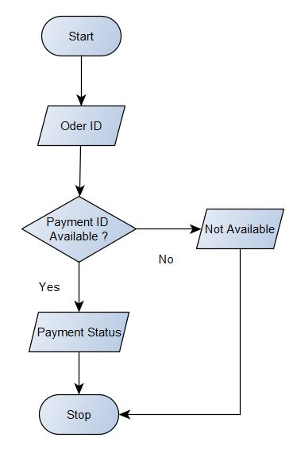
2.6 Gantt Chart
Gantt chart was invented by a mechanical engineer named Henry Gantt in 1910. A gantt chart is simply a type of bar chart that visually represents a project plan over time. It shows start and end dates for tasks, displays milestones, and allows for dependencies between tasks. With all the features of Henry gantt’s project management system, it’s no wonder that even now, more than 100 years later, the gantt chart is still the preferred tool for managing projects of all sizes and types.
Week | 1 | 2 | 3 | 4 | 5 | 6 | 7 | 8 | 9 | 10 | 11 | 12
Activities
Research
Define Specification
Project Planning
Design
Development
Test Plan
Testing and Q A
Delivery

2.7 Class Diagram
Class diagrams are the main building block in object-oriented modeling. They are used to show the different objects in a system, their attributes, their operations and the relationships among them.
Classes in class diagrams are represented by boxes that are partitioned into three:-
- The top partition contains the name of the class.
- The middle part contains the class’s attributes.
- The bottom partition shows the possible operations that are associated with the class.
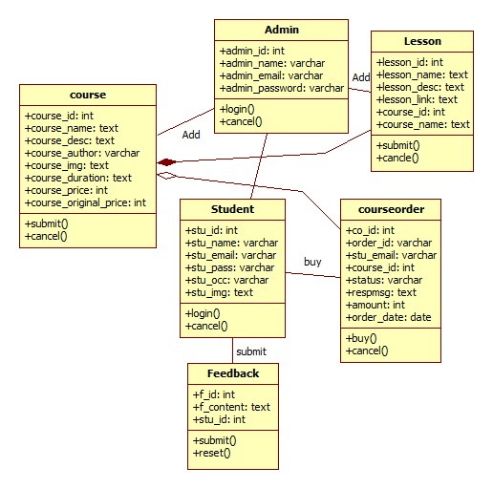

- System Design
The systems design approach first appeared right before World War II, when engineers were trying to solve complex control and communications problems. They needed to be able to standardize their work into a formal discipline with proper methods, especially for new fields like information theory, operations research and computer science in general. System design is the process of defining the elements of a system such as the architecture, modules and components, the different interfaces of those components and the data that goes through that system. It is meant to satisfy specific needs and requirements of a business or organization through the engineering of a coherent and well-running system.
3.1 Input Module
In order to complete the tasks of iSchool and to get output by using this application work, there is need of some input based on the work that is to be carried out by using it. Different kinds of input are required for different purposes.
- Student/Learner Registration
- Course
- Lesson
- Feedback
- Payment Status

3.2 Output Module
The project named “iSchool E-Learning Management System” is being made keeping in mind to solve the activities that are carried out in the Education. By using this, Admin can easily do many things like as:
- Student/Learner List
- Course Detail
- Lesson Detail
- Sell Report
- Payment Receipt

3.3 Modularization Detail
Without Registration
- Home – This module contains all the links of the application such as Courses, Payment Status, Login, Sign Up, Feedback Section and Contact.
- Courses – This module contains list of all the courses which are available at iSchool.
- Payment Status – This module is used to check Payment status after purchasing a course.
- Login – This module is used to login into Student/Learner Panel.
- Sign Up – This module is used to register for the Student/Learner Panel.
- Feedback – This section shows feedback given by registered students/learners.
- Contact – Learner can use this section to contact the admin/tutor for any kind of queries.

Student Panel
- Profile – This module contains all the details about Student/Learner as well as Student can update their details.
- My Courses – This module contains list of all purchased courses.
- Feedback – This module is used to write feedback.
- Change Password – Students can use this module to change password.
- Logout – This module is used to return back to Home Page.

Admin Panel
- Dashboard – This module displays overview of whole application.
- Courses – This module contains all the courses.
- Lessons – This module contains all the lesson depends on course id.
- Students – This module displays all the registered student details.
- Sell Report – This module is used to view and print sells report.
- Payment Status – This module displays payment status in more details.
- Feedback – This module displays feedback given by students.
- Change Password – Admin can use this module to change password.
- Logout – This module is used to return back to Home Page.

3.4 Process Logic
Home:
When the user click on this tab, it will display the other modules and pages of the website such as courses, payment status, login, sign up, popular section, feedback section, contact and admin login. This module will be used to display the brief introduction of the project and will show the title of the project.

Courses:
Student can view all available courses by clicking on courses tab where he can choose course according to his own interest and by clicking on a particular course, will display more details with lesson title of the course, if he wants to purchase he will be able to make payment (required login).
Payment Status:
After purchasing course student will be provided an order id which can be used to get the status of payment using Payment status tab. If student wants he can get print out of his payment status.
Login:
This is a login form. Student/Learner can use their own email and password to login into the student panel.
Sign Up:
This is a Registration form for new Students/Learners. New Students/Learners can fill up the form for registration and after successful registration they can use their email id and password to login into the application.
Feedback:
This is very simple section which displays feedback given by the registered student.
Contact:
Learner can use this section to contact the admin/tutor for any kind of queries.

Student Panel:-
Profile:
Students/Learners can view their student id, registered email id, name, occupation, profile picture as well as they can modify and update the new data if they need.
My Courses:
Students can view all courses which they purchased. This is the place where they can start watching lectures by clicking on Watch Course button which leads to course playlist where they can watch the entire lesson of course.
Feedback:
Students can view/write feedback.
Change Password:
Students can use this module to change password.
Logout:
This module is used exit student panel and return back to Home Page.

Admin Panel
Dashboard:
This module displays overview of whole application such as number of course, number of registered students etc.
Courses:
This is the most important module of admin panel where Admin can view list of course as well as add new courses and modify or delete courses.
Lessons:
Admin can view lesson based on course id as well as new lesson can be added to the course and modification or deletion is also possible using this module.
Students:
Admin can view registered students details. Admin can add, edit and delete student.
Feedback:
Admin can view/delete feedback given by student.
Sell Report:
Analyzing sales is very import for any kind of business and this module is perfect for analyzing sales based on date. It will generate sells report which can be possible to print out for office records.
Payment Status:
If student file any complaints regarding payment Admin can use this module to display payment status in more details such as bank name, transaction id, payment date etc.
Change Password:
Admin can use change password.
Logout:
This module is used exit admin panel and return back to Home Page.

3.5 Data Integrity
Data integrity is the overall completeness, accuracy and consistency of data. This can be indicated by the absence of alteration between two instances or between two updates of a data record, meaning data is intact and unchanged. Data integrity is usually imposed during the database design phase through the use of standard procedures and rules. The concept of data integrity ensures that all data in a database can be traced and connected to other data. This ensures that everything is recoverable and searchable. Having a single, well-defined and well-controlled data integrity system increases stability, performance, reusability and maintainability. Data values are standardized according to a data model and data type. All characteristics of the data must be correct including business rules, relations, dates and definitions for data to be complete. Data integrity is imposed within a database when it is designed and is authenticated through the ongoing use of error checking and validation routines. As a simple example, to maintain data integrity numeric columns/cells should not accept alphabetic data.

3.6 Data Dictionary
A data dictionary contains a list of all files in the database, the number of records in each file, and the names and types of each field. Most database management systems keep the data dictionary hidden from users to prevent them from accidentally destroying its contents. For most relational database management systems (RDBMS), the database management system software needs the data dictionary to access the data within a database. For example, the MySQL Database software has to read and write to an MySQL Database. However, it can only do this via the data dictionary created for that particular database.

Table Name: Admin (Stores Admin Detail)
Attribute | Data Type | Description
admin_id # | int(11) | Stores Admin ID
admin_name | varchar(255) | Stores Admin Name
admin_email | varchar(255) | Stores Admin Email ID
admin_pass | varchar(255) | Stores Admin Password

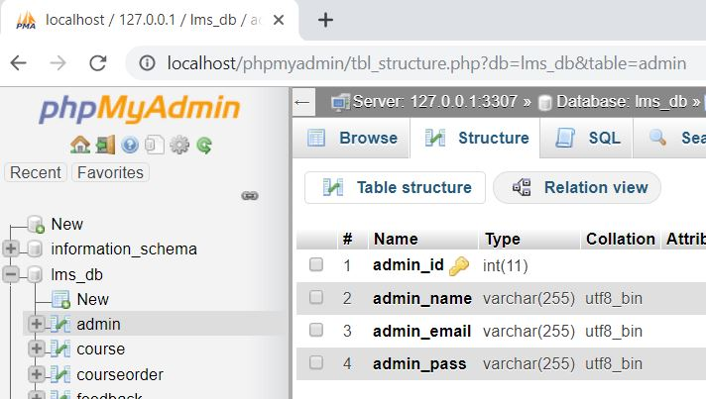

Table Name: Student (Stores Student Detail)
Attribute | Data Type | Description
stu_id # | int(11) | Stores student ID
stu_name | varchar(255) | Stores student Name
stu_email | varchar(255) | Stores student Email ID
stu_pass | varchar(255) | Stores student Password
stu_occ | varchar(255) | Stores student occupation
stu_img | text | Stores student profile picture

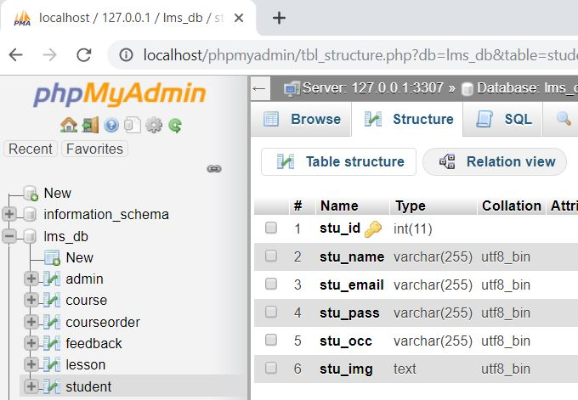

Table Name: Feedback (Stores Feedback Detail)
Attribute | Data Type | Description
f_id # | int(11) | Stores Feedback ID
f_content | text | Stores Feedback content
stu_id | int(11) | Stores Student ID

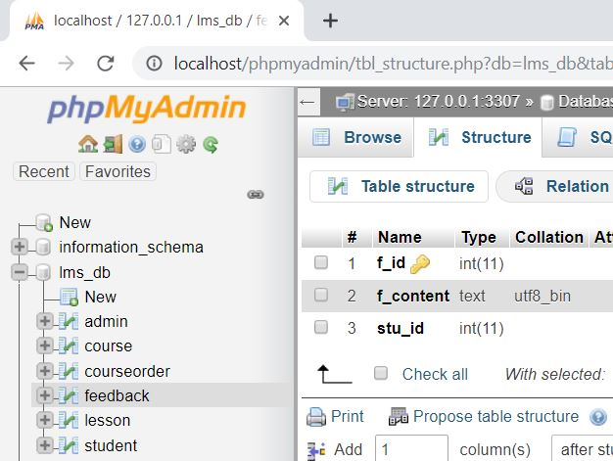

Table Name: course (Stores Course Detail)
Attribute | Data Type | Description
course_id # | int(11) | Stores Course ID
course_name | text | Stores course Name
course_desc | text | Stores course description
course_author | varchar(255) | Stores course author/instructor
course_img | text | Stores course display picture
course_duration | text | Stores course duration
course_price | int(11) | Stores course selling price
course_original_price | int(11) | Stores course original price

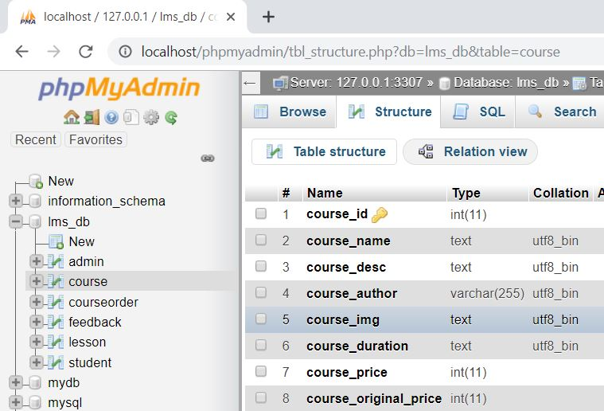

Table Name: Lesson (Stores Lesson Detail)
Attribute | Data Type | Description
lesson_id # | int(11) | Stores Lesson ID
lesson_name | text | Stores Lesson name
lesson_desc | text | Stores lesson description
lesson_link | text | Stores lesson video link/video file
course_id | int(11) | Stores course ID
course_name | text | Stores course Name

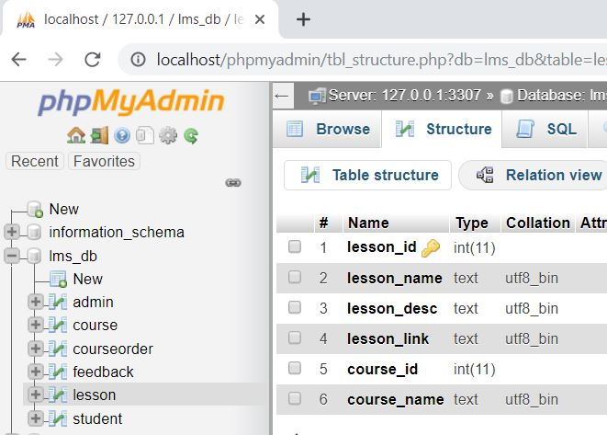

Table Name: courseorder (Stores Course order Detail)
Attribute | Data Type | Description
co_id # | int(11) | Stores course order ID
order_id | varchar(255) | Stores Order ID (Random)
stu_email | varchar(255) | Stores student email id
course_id | int(11) | Stores course id
status | varchar(255) | Stores payment status
respmsg | text | Stores payment response msg
amount | int(11) | Stores course amount
order_date | date | Stores purchase date

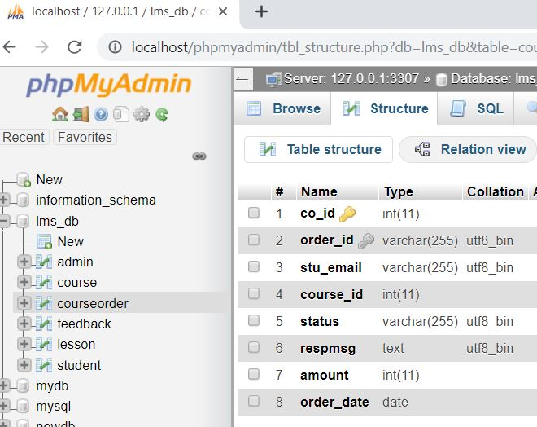

3.7 User Interface Design
User interface design is concerned with the dialogue between a user and the computer. It is concerned with everything from starting the system or logging into the system to the eventually presentation of desired inputs and outputs. The overall flow of screens and messages is called a dialogue.
- It should be attractive and simple to use.
- The system user should always be aware of what to do next.
- Messages, instruction and information should be displayed long enough to allow the system user to read them.
- An user should not be allowed to proceed without correcting an error.
- An user should never get an fatal error instead provide them understanble errors.

- Tools and Environment

4.1 Hardware Requirements
Processor | 1.6 GHz or Faster Processor
RAM | 4 GB
Disk Space | 10 GB of Available Hard Disk
Graphic | DirectX 9-Capable Video Card
Display | 1024 X 768 or Higher Resolution

4.2 Software Requirements
Operating System | Windows 10
Front End | HTML, CSS, JavaScript
Back End | PHP
Library/ Framework | Bootstrap, JQuery, FontAwesome
Plugins  Code Editor | Owl Carousel
Plugins  Code Editor | Visual Studio Code 1.33
Database | MySQL
Web Server | Apache
Web Browser | Google Chrome
Payment Gateway | Paypal
Drawing Tools | yEd Graph Editor
Drawing Tools | StarUML

- Software Description

5.1 PHP

PHP is an open source language and all its components are free to use and distribute. PHP is server-side scripting language. It is embedded in HTML source code. PHP supports all major web servers such as Apache, Microsoft IIS and Netscape etc. All the major database such as Mysql, PostgreSQL, Oracle, Sybase, Microsoft SQL Server is supported by PHP. Following are the some major advantage:-
- Friendly With HTML - PHP and HTML are interchangeable within the page. You can put PHP outside the HTML or inside.
- Interactive Features - PHP allows you to interact with your visitors in ways HTML alone can't.
- Top-Notch Online Documentation - The PHP documentation is the best on the web. Hands down.
- Compatible With Databases - A good benefit of using PHP is that it can interact with many different database languages including MySQL.

5.2 MySQL

MySQL is the most popular open source relational database management system. It is one of the best RDBMS being used to develop web-based applications. It is easy to use and fast RDBMS. Following are the top reason to use MySQL:-
- High Performance
- Robust Transactional Support
- Strong Data Protection
- Open Source Freedom
5.3 HTML

Hypertext Markup Language (HTML) is the standard markup language for creating web pages and web applications. With Cascading Style Sheets (CSS) and JavaScript, it forms a triad of cornerstone technologies for the World Wide Web.
Web browsers receive HTML documents from a web server or from local storage and render the documents into multimedia web pages. HTML describes the structure of a web page semantically and originally included cues for the appearance of the document.

5.4 CSS

Cascading Style Sheets (CSS) is a style sheet language used for describing the presentation of a document written in a markup language like HTML. CSS is a cornerstone technology of the World Wide Web, alongside HTML and JavaScript.
CSS is designed to enable the separation of presentation and content, including layout, colors, and fonts. This separation can improve content accessibility, provide more flexibility and control in the specification of presentation characteristics, enable multiple web pages to share formatting by specifying the relevant CSS in a separate .css file, and reduce complexity and repetition in the structural content.

5.5 JavaScript

JavaScript often abbreviated as JS, is a high-level, interpreted programming language. It is a language which is also characterized as dynamic, weakly typed, prototype-based and multi-paradigm.

5.6 Bootstrap

Bootstrap is an open source toolkit for developing with HTML, CSS, and JS. Quickly prototype your ideas or build your entire app with our Sass variables and mixins, responsive grid system, extensive prebuilt components, and powerful plugins built on jQuery. Build responsive, mobile-first projects on the web with the world’s most popular front-end component library.

5.7 Paypal Payment Gateway

Collecting Online Payment for any kind of business is much eaiser with Paypal Payment Gateway. It provides a secure, PCI-compliant way to accept Debit/Credit card, and Paypal wallet payments from your customers. It also provides cancellations feature. It helps to make genuine cancellations a positive experience and maintain customer loyalty.

5.8 Visual Studio Code

Visual Studio Code was announced on April 29, 2015 by Microsoft at the 2015 Build conference. A Preview build was released shortly thereafter.
On November 18, 2015, Visual Studio Code was released under the MIT License and its source code posted to GitHub. Extension support was also announced.
On April 14, 2016, Visual Studio Code graduated the public preview stage and was released to web.Visual Studio Code is a source code editor developed by Microsoft for Windows, Linux and macOS. It includes support for debugging, embedded Git control, syntax highlighting, intelligent code completion, snippets, and code refactoring. It is also customizable, so users can change the editor's theme, keyboard shortcuts, and preferences. It is free and open-source, although the official download is under a proprietary license.

5.9 yEd Graph Editor

yEd is a powerful Free Desktop Application that can be used to quickly and effectively generate high-quality diagrams. yEd can be used to draw many different types of diagrams, including flowcharts, network diagrams, UMLs, BPMN, mind maps, organization charts, and entity-relationship diagrams. yEd can automatically arrange diagram elements using a variety of graph layout algorithms. The program works much like many similar applications.
yEd can export diagrams to various raster and vector formats, including GIF, JPEG, PNG, EMF, BMP, PDF, EPS, and SVG.

5.10 StarUML

StarUML is an open source project to develop fast, flexible, extensible and featureful diagrams . With StarUML it is very easy to make Class Diagram. StarUML is implemented to provide many user-friend features such as Quick dialog, Keyboard manipulation, Diagram overview, etc.

- Program Code

dbConnection.php
<?php
$db_host = "localhost:3307";
$db_user = "root";
$db_password = "";
$db_name = "lms_db";

// Create Connection
$conn = new mysqli($db_host, $db_user, $db_password, $db_name);

// Check Connection
if($conn->connect_error) {
die("connection failed");
}
// else {
// echo"connected";
// }
?>

./mainInclude/header.php

<!DOCTYPE html>
<html lang="en">
<head>
<meta charset="UTF-8" />
<meta name="viewport" content="width=device-width, initial-scale=1.0" />
<meta http-equiv="X-UA-Compatible" content="ie=edge" />

<!-- Bootstrap CSS -->
<link rel="stylesheet" type="text/css" href="css/bootstrap.min.css">

<!-- Font Awesome CSS -->
<link rel="stylesheet" type="text/css" href="css/all.min.css">

<!-- Google Font -->
<link href="https://fonts.googleapis.com/css?family=Ubuntu" rel="stylesheet">

<!-- Student Testimonial Owl Slider CSS -->
<link rel="stylesheet" type="text/css" href="css/owl.min.css">
<link rel="stylesheet" type="text/css" href="css/owl.theme.min.css">
<link rel="stylesheet" type="text/css" href="css/testyslider.css">

<!-- Custom Style CSS -->
<link rel="stylesheet" type="text/css" href="./css/style.css" />
<title>iSchool</title>
</head>
<body>
<!-- Start Nagigation -->
<nav class="navbar navbar-expand-sm navbar-dark pl-5 fixed-top">
<a href="index.php" class="navbar-brand">iSchool</a>
<span class="navbar-text">Learn and Implement</span>
<button type="button" class="navbar-toggler" data-toggle="collapse" data-target="#myMenu">
<span class="navbar-toggler-icon"></span>
</button>
<div class="collapse navbar-collapse" id="myMenu">
<ul class="navbar-nav pl-5 custom-nav">
<li class="nav-item custom-nav-item"><a href="index.php" class="nav-link">Home</a></li>
<li class="nav-item custom-nav-item"><a href="courses.php" class="nav-link">Courses</a></li>
<li class="nav-item custom-nav-item"><a href="paymentstatus.php" class="nav-link">Payment Status</a></li>
<?php
session_start();
if (isset($_SESSION['is_login'])){
echo '<li class="nav-item custom-nav-item"><a href="student/studentProfile.php" class="nav-link">My Profile</a></li> <li class="nav-item custom-nav-item"><a href="logout.php" class="nav-link">Logout</a></li>';
} else {
echo '<li class="nav-item custom-nav-item"><a href="#login" class="nav-link" data-toggle="modal" data-target="#stuLoginModalCenter">Login</a></li> <li class="nav-item custom-nav-item"><a href="#signup" class="nav-link" data-toggle="modal" data-target="#stuRegModalCenter">Signup</a></li>';
}
?>
<li class="nav-item custom-nav-item"><a href="#Feedback" class="nav-link">Feedback</a></li>
<li class="nav-item custom-nav-item"><a href="#Contact" class="nav-link">Contact</a></li>
</ul>
</div>
</nav> <!-- End Navigation -->

./mainInclude/footer.php

<!-- Start Footer -->
<footer class="container-fluid bg-dark text-center p-2">
<small class="text-white">Copyright &copy; 2019 || Designed By E-Learning || <?php
if (isset($_SESSION['is_admin_login'])){
echo '<a href="admin/adminDashboard.php"> Admin Dashboard</a> <a href="logout.php">Logout</a>';
}else {
echo '<a href="#login" data-toggle="modal" data-target="#adminLoginModalCenter"> Admin Login</a>';
}
?>
</small>

</footer> <!-- End Footer -->

<!-- Start Student Registration Modal -->
<div class="modal fade" id="stuRegModalCenter" tabindex="-1" role="dialog" aria-labelledby="stuRegModalCenterTitle" aria-hidden="true">
<div class="modal-dialog modal-dialog-centered" role="document">
<div class="modal-content">
<div class="modal-header">
<h5 class="modal-title" id="stuRegModalCenterTitle">Student Registration</h5>
<button type="button" class="close" data-dismiss="modal" aria-label="Close" onclick="clearAllStuReg()">
<span aria-hidden="true">&times;</span>
</button>
</div>
<div class="modal-body">
<!--Start Form Registration-->
<?php include('studentRegistration.php'); ?>
<!-- End Form Registration -->
</div>
<div class="modal-footer">
<span id="successMsg"></span>
<button type="button" class="btn btn-primary" id="signup" onclick="addStu()">Sign Up</button>
<button type="button" class="btn btn-secondary" data-dismiss="modal" onclick="clearAllStuReg()">Close</button>
</div>
</div>
</div>
</div> <!-- End Student Registration Modal -->

<!-- Start Student Login Modal -->
<div class="modal fade" id="stuLoginModalCenter" tabindex="-1" role="dialog" aria-labelledby="stuLoginModalCenterTitle" aria-hidden="true">
<div class="modal-dialog modal-dialog-centered" role="document">
<div class="modal-content">
<div class="modal-header">
<h5 class="modal-title" id="stuLoginModalCenterTitle">Student Login</h5>
<button type="button" class="close" data-dismiss="modal" aria-label="Close" onClick="clearStuLoginWithStatus()">
<span aria-hidden="true">&times;</span>
</button>
</div>
<div class="modal-body">
<form role="form" id="stuLoginForm">
<div class="form-group">
<i class="fas fa-envelope"></i><label for="stuLogEmail" class="pl-2 font-weight-bold">Email</label><small id="statusLogMsg1"></small><input type="email"
class="form-control" placeholder="Email" name="stuLogEmail" id="stuLogEmail">
</div>
<div class="form-group">
<i class="fas fa-key"></i><label for="stuLogPass" class="pl-2 font-weight-bold">Password</label><input type="password" class="form-control" placeholder="Password" name="stuLogPass" id="stuLogPass">
</div>
</form>
</div>
<div class="modal-footer">
<small id="statusLogMsg"></small>
<button type="button" class="btn btn-primary" id="stuLoginBtn" onclick="checkStuLogin()">Login</button>
<button type="button" class="btn btn-secondary" data-dismiss="modal" onClick="clearStuLoginWithStatus()">Cancel</button>
</div>
</div>
</div>
</div> <!-- End Student Login Modal -->

<!-- Start Admin Login Modal -->
<div class="modal fade" id="adminLoginModalCenter" tabindex="-1" role="dialog" aria-labelledby="adminLoginModalCenterTitle" aria-hidden="true">
<div class="modal-dialog modal-dialog-centered" role="document">
<div class="modal-content">
<div class="modal-header">
<h5 class="modal-title" id="adminLoginModalCenterTitle">Admin Login</h5>
<button type="button" class="close" data-dismiss="modal" aria-label="Close" onClick="clearAdminLoginWithStatus()">
<span aria-hidden="true">&times;</span>
</button>
</div>
<div class="modal-body">
<form role="form" id="adminLoginForm">
<div class="form-group">
<i class="fas fa-envelope"></i><label for="adminLogEmail" class="pl-2 font-weight-bold">Email</label><input type="email"
class="form-control" placeholder="Email" name="adminLogEmail" id="adminLogEmail">
</div>
<div class="form-group">
<i class="fas fa-key"></i><label for="adminLogPass" class="pl-2 font-weight-bold">Password</label><input type="password" class="form-control" placeholder="Password" name="adminLogPass" id="adminLogPass">
</div>
</form>
</div>
<div class="modal-footer">
<small id="statusAdminLogMsg"></small>
<button type="button" class="btn btn-primary" id="adminLoginBtn" onclick="checkAdminLogin()">Login</button>
<button type="button" class="btn btn-secondary" data-dismiss="modal" onClick="clearAdminLoginWithStatus()">Cancel</button>
</div>
</div>
</div>
</div> <!-- End Admin Login Modal -->

<!-- Jquery and Boostrap JavaScript -->
<script type="text/javascript" src="js/jquery.min.js"></script>
<script type="text/javascript" src="js/popper.min.js"></script>
<script type="text/javascript" src="js/bootstrap.min.js"></script>

<!-- Font Awesome JS -->
<script type="text/javascript" src="js/all.min.js"></script>

<!-- Student Testimonial Owl Slider JS -->
<script type="text/javascript" src="js/owl.min.js"></script>
<script type="text/javascript" src="js/testyslider.js"></script>

<!-- Student Ajax Call JavaScript -->
<script type="text/javascript" src="js/ajaxrequest.js"></script>

<!-- Admin Ajax Call JavaScript -->
<script type="text/javascript" src="js/adminajaxrequest.js"></script>

<!-- Custom JavaScript -->
<script type="text/javascript" src="js/custom.js"></script>

</body>

</html>

contact.php

<!--Start Contact Us-->
<div class="container mt-4" id="Contact"> <!--Start Contact Us Container-->
<h2 class="text-center mb-4">Contact US</h2> <!-- Contact Us Heading -->
<div class="row"> <!--Start Contact Us Row-->
<div class="col-md-8"> <!--Start Contact Us 1st Column-->
<form action="" method="post">
<input type="text" class="form-control" name="name" placeholder="Name"><br>
<input type="text" class="form-control" name="subject" placeholder="Subject"><br>
<input type="email" class="form-control" name="email" placeholder="E-mail"><br>
<textarea class="form-control" name="message" placeholder="How can we help you?" style="height:150px;"></textarea><br>
<input class="btn btn-primary" type="submit" value="Send" name="submit"><br><br>
</form>
</div> <!-- End Contact Us 1st Column-->

<div class="col-md-4 stripe text-white text-center"> <!-- Start Contact Us 2nd Column-->
<h4>iSchool</h4>
<p>iSchool,
Near Police Camp II, Bokaro,
Jharkhand - 834005<br />
Phone: +00000000 <br />
www.ischool.com </p>
</div> <!-- End Contact Us 2nd Column-->
</div> <!-- End Contact Us Row-->
</div> <!-- End Contact Us Container-->
<!-- End Contact Us -->

studentRegistration.php
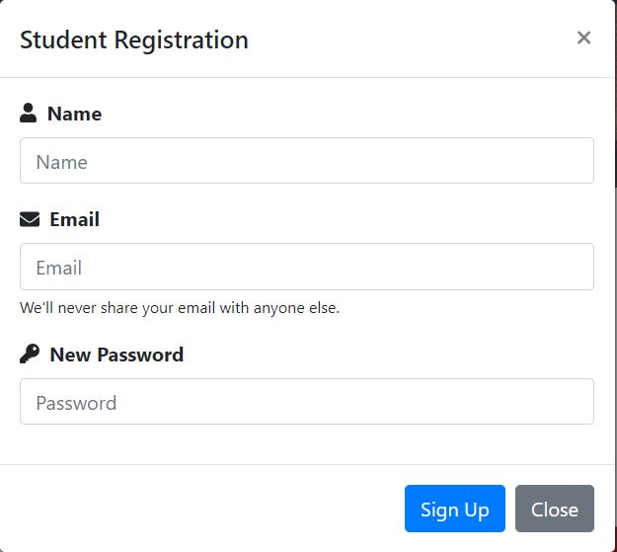
<form role="form" id="stuRegForm">
<div class="form-group">
<i class="fas fa-user"></i><label for="stuname" class="pl-2 font-weight-bold">Name</label><small id="statusMsg1"></small><input type="text"
class="form-control" placeholder="Name" name="stuname" id="stuname">
</div>
<div class="form-group">
<i class="fas fa-envelope"></i><label for="stuemail" class="pl-2 font-weight-bold">Email</label><small id="statusMsg2"></small><input type="email"
class="form-control" placeholder="Email" name="stuemail" id="stuemail">
<small class="form-text">We'll never share your email with anyone else.</small>
</div>
<div class="form-group">
<i class="fas fa-key"></i><label for="stupass" class="pl-2 font-weight-bold">New
Password</label><small id="statusMsg3"></small><input type="password" class="form-control" placeholder="Password" name="stupass" id="stupass">
</div>
</form>

loginorsignup.php
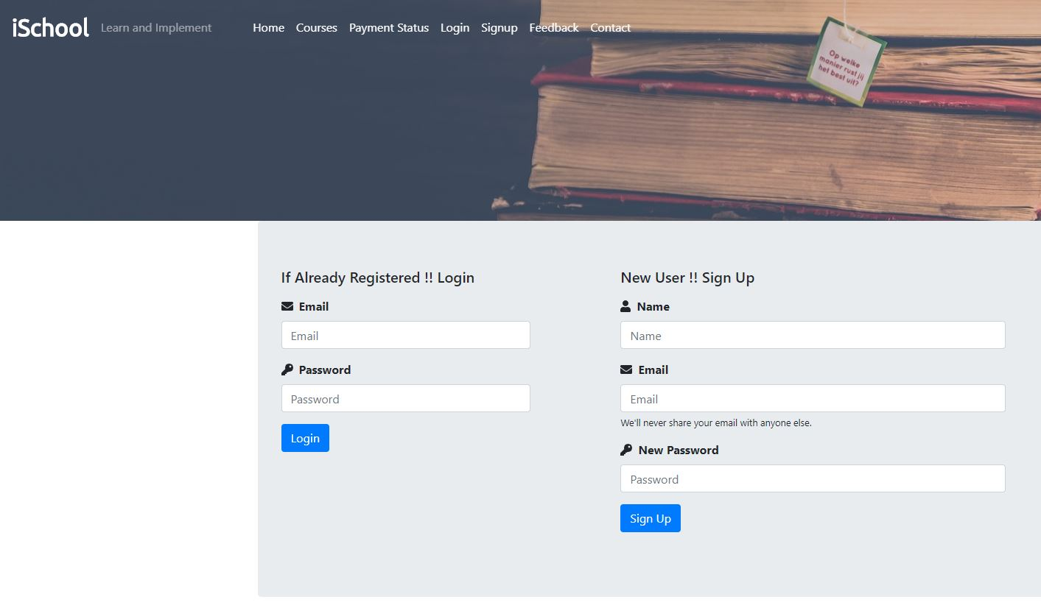
<?php
include('./dbConnection.php');
// Header Include from mainInclude
include('./mainInclude/header.php');
?>
<div class="container-fluid bg-dark"> <!-- Start Course Page Banner -->
<div class="row">
<img src="./image/coursebanner.jpg" alt="courses" style="height:300px; width:100%; object-fit:cover; box-shadow:10px;"/>
</div>
</div> <!-- End Course Page Banner -->

<div class="container jumbotron mb-5">
<div class="row">
<div class="col-md-4">
<h5 class="mb-3">If Already Registered !! Login</h5>
<form role="form" id="stuLoginForm">
<div class="form-group">
<i class="fas fa-envelope"></i><label for="stuLogEmail" class="pl-2 font-weight-bold">Email</label><small id="statusLogMsg1"></small><input type="email"
class="form-control" placeholder="Email" name="stuLogEmail" id="stuLogEmail">
</div>
<div class="form-group">
<i class="fas fa-key"></i><label for="stuLogPass" class="pl-2 font-weight-bold">Password</label><input type="password" class="form-control" placeholder="Password" name="stuLogPass" id="stuLogPass">
</div>
<button type="button" class="btn btn-primary" id="stuLoginBtn" onclick="checkStuLogin()">Login</button>
</form><br/>
<small id="statusLogMsg"></small>
</div>
<div class="col-md-6 offset-md-1">
<h5 class="mb-3">New User !! Sign Up</h5>
<form role="form" id="stuRegForm">
<div class="form-group">
<i class="fas fa-user"></i><label for="stuname" class="pl-2 font-weight-bold">Name</label><small id="statusMsg1"></small><input type="text"
class="form-control" placeholder="Name" name="stuname" id="stuname">
</div>
<div class="form-group">
<i class="fas fa-envelope"></i><label for="stuemail" class="pl-2 font-weight-bold">Email</label><small id="statusMsg2"></small><input type="email"
class="form-control" placeholder="Email" name="stuemail" id="stuemail">
<small class="form-text">We'll never share your email with anyone else.</small>
</div>
<div class="form-group">
<i class="fas fa-key"></i><label for="stupass" class="pl-2 font-weight-bold">New
Password</label><small id="statusMsg3"></small><input type="password" class="form-control" placeholder="Password" name="stupass" id="stupass">
</div>
<button type="button" class="btn btn-primary" id="signup" onclick="addStu()">Sign Up</button>
</form> <br/>
<small id="successMsg"></small>
</div>
</div>
</div>
<hr/>

<?php
// Contact Us
include('./contact.php');
?>

<?php
// Footer Include from mainInclude
include('./mainInclude/footer.php');
?>

checkout.php
<?php
include('./dbConnection.php');
session_start();
if(!isset($_SESSION['stuLogEmail'])) {
echo "<script> location.href='loginorsignup.php'; </script>";
} else {
$stuEmail = $_SESSION['stuLogEmail'];
?>

<!DOCTYPE html>
<html lang="en">
<head>
<meta charset="UTF-8">
<meta name="viewport" content="width=device-width, initial-scale=1.0">
<meta http-equiv="X-UA-Compatible" content="ie=edge">

<!-- Bootstrap CSS -->
<link rel="stylesheet" type="text/css" href="css/bootstrap.min.css">

<!-- Font Awesome CSS -->
<link rel="stylesheet" type="text/css" href="css/all.min.css">

<!-- Google Font -->
<link href="https://fonts.googleapis.com/css?family=Ubuntu" rel="stylesheet">

<!-- Custom Style CSS -->
<link rel="stylesheet" type="text/css" href="./css/style.css" />

<title>Checkout</title>
</head>
<body>
<div class="container mt-5">
<div class="row">
<div class="col-sm-6 offset-sm-3 jumbotron">
<h3 class="mb-5">Welcome to E-Learning Payment Page</h3>
<form method="post" action="./paymentdone.php" id="myform">
<div class="form-group row">
<label for="ORDER_ID" class="col-sm-4 col-form-label">Order ID</label>
<div class="col-sm-8">
<input id="ORDER_ID" class="form-control" tabindex="1" maxlength="20" size="20" name="ORDER_ID" autocomplete="off"
value="<?php echo "ORDS" . rand(10000,99999999)?>" readonly>
</div>
</div>
<div class="form-group row">
<label for="CUST_ID" class="col-sm-4 col-form-label">Student Email</label>
<div class="col-sm-8">
<input id="CUST_ID" class="form-control" tabindex="2" maxlength="12" size="12" name="CUST_ID" autocomplete="off" value="<?php if(isset($stuEmail)){echo $stuEmail; }?>" readonly>
</div>
</div>
<div class="form-group row">
<label for="TXN_AMOUNT" class="col-sm-4 col-form-label">Amount</label>
<div class="col-sm-8">
<input title="TXN_AMOUNT" class="form-control" tabindex="10"
type="text" name="TXN_AMOUNT" value="<?php if(isset($_POST['id'])){echo $_POST['id']; }?>" readonly>
</div>
</div>
<div class="text-center">
<!-- Set up a container element for the button -->
<div id="paypal-button-container"></div>
<a href="./courses.php" class="btn btn-secondary">Cancel</a>
</div>
</form>
<small class="form-text text-muted">Note: Complete Payment by Clicking Checkout Button</small>
</div>
</div>
</div>

<!-- Include the PayPal JavaScript SDK -->
<script src="https://www.paypal.com/sdk/js?client-id=sb&currency=USD"></script>

<script>
// Render the PayPal button into #paypal-button-container
paypal.Buttons({

// Set up the transaction
createOrder: function(data, actions) {
return actions.order.create({
purchase_units: [{
amount: {
value: '<?php if(isset($_POST['id'])){echo $_POST['id']; }?>'
}
}]
});
},
// Finalize the transaction
onApprove: function(data, actions) {
return actions.order.capture().then(function(details) {
// Show a success message to the buyer
alert('Transaction completed by ' + details.payer.name.given_name + '!');
document.getElementById("myform").submit()
});
}
}).render('#paypal-button-container');

</script>
<!-- Jquery and Boostrap JavaScript -->
<script type="text/javascript" src="js/jquery.min.js"></script>

<script type="text/javascript" src="js/popper.min.js"></script>

<script type="text/javascript" src="js/bootstrap.min.js"></script>

<!-- Font Awesome JS -->
<script type="text/javascript" src="js/all.min.js"></script>

<!-- Custom JavaScript -->
<script type="text/javascript" src="js/custom.js"></script>

</body>
</html>
<?php } ?>

Paymentdone.php

<?php
include('./dbConnection.php');
session_start();
if(!isset($_SESSION['stuLogEmail'])) {
echo "<script> location.href='loginorsignup.php'; </script>";
} else {
date_default_timezone_set('Asia/Kolkata');
$date = date('d-m-y h:i:s');
if(isset($_POST['ORDER_ID']) && isset($_POST['TXN_AMOUNT'])){
$order_id = $_POST['ORDER_ID'];
$stu_email = $_SESSION['stuLogEmail'];
$course_id = $_SESSION['course_id'];
$status = "Success";
$respmsg = "Done";
$amount = $_POST['TXN_AMOUNT'];
$date = $date;
$sql = "INSERT INTO courseorder(order_id, stu_email, course_id, status, respmsg, amount, order_date) VALUES ('$order_id', '$stu_email', '$course_id', '$status', '$respmsg', '$amount', '$date')";
if($conn->query($sql) == TRUE){
echo "Redirecting to My Profile....";
echo "<script> setTimeout(() => {
window.location.href = './Student/myCourse.php';
}, 1500); </script>";
};
} else {
echo "<b>Transaction status is failure</b>" . "<br/>";
}
}
?>

Paymentstatus.php

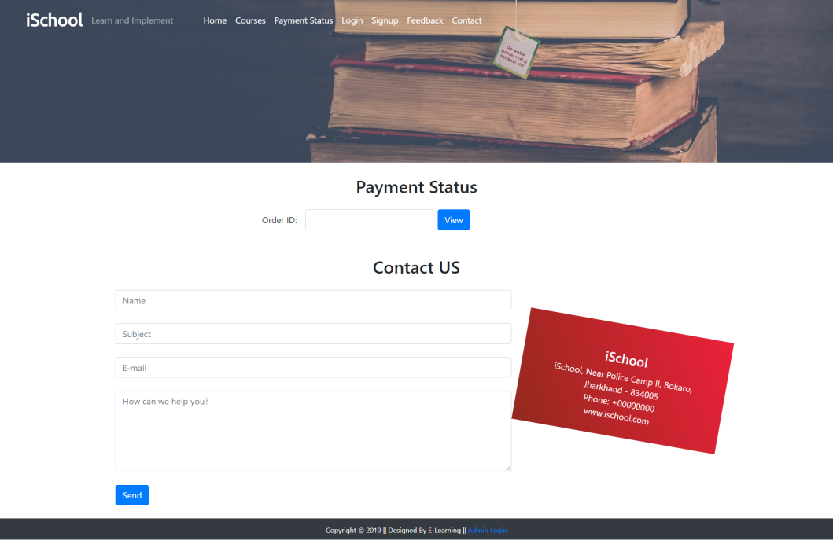
<?php
include('./dbConnection.php');
// Header Include from mainInclude
include('./mainInclude/header.php');

$ORDER_ID = "";

if (isset($_POST["ORDER_ID"]) && $_POST["ORDER_ID"] != "") {
$ORDER_ID = $_POST["ORDER_ID"];
}

?>
<div class="container-fluid bg-dark"> <!-- Start Course Page Banner -->
<div class="row">
<img src="./image/coursebanner.jpg" alt="courses" style="height:300px; width:100%; object-fit:cover; box-shadow:10px;"/>
</div>
</div> <!-- End Course Page Banner -->
<div class="container">
<h2 class="text-center my-4">Payment Status </h2>
<form method="post" action="">
<div class="form-group row">
<label class="offset-sm-3 col-form-label">Order ID: </label>
<div>
<input class="form-control mx-3" id="ORDER_ID" tabindex="1" maxlength="20" size="20" name="ORDER_ID" autocomplete="off" value="<?php echo $ORDER_ID ?>">
</div>
<div>
<input class="btn btn-primary mx-4" value="View" type="submit" onclick="">
</div>
</div>
</form>
</div>
<div class="container">
<?php
if (isset($_POST['ORDER_ID']))
{
$sql = "SELECT order_id FROM courseorder";
$result = $conn->query($sql);
while($row = $result->fetch_assoc()){
if($_POST["ORDER_ID"] == $row["order_id"]){ ?>
<div class="row justify-content-center">
<div class="col-auto">
<h2 class="text-center">Payment Receipt</h2>
<table class="table table-bordered">
<tbody>
<tr >
<td><label>Order ID</label></td>
<td><?php if (isset($row["order_id"])) echo $row["order_id"] ?></td>
</tr>
<tr >
<td><label>Status</label></td>
<td>Success</td>
</tr>
<tr>
<td></td>
<td><button class="btn btn-primary" onclick="javascript:window.print();">Print Receipt</button></td>
</tr>
</tbody>
</table>
</div>
</div>
<?php
} } } ?>

</div>
<div class="mt-5">
<?php
// Contact Us
include('./contact.php');
?>
</div>

<?php
// Footer Include from mainInclude
include('./mainInclude/footer.php');
?>

Logout.php

<?php
session_start();
session_destroy();
echo "<script> location.href='index.php'; </script>";
?>

style.css
.navbar-brand {
font-family: "Ubuntu", sans-serif;
font-size: 2em;
font-weight: bold;
color: #fff;
}

.custom-nav .custom-nav-item a {
color: #fff !important;
}

.custom-nav-item:hover {
background-color: #dc3545;
border: solid #dc3545 1px;
border-radius: 10px;
}

.remove-vid-marg {
margin: 0px;
padding: 0px;
}

.vid-parent {
position: relative;
}
video {
width: 100%;
height: 100%;
}
.vid-overlay {
position: absolute;
top: 0;
left: 0;
height: 100%;
width: 100%;
background-color: #225470;
z-index: 1;
opacity: 0.8;
}

.vid-content {
color: #fff;
position: absolute;
top: 35%;
left: 35%;
z-index: 2;
text-align: center;
}

.bottom-banner {
color: #fff;
padding: 10px;
}

.bottom-banner:first-child {
padding-left: 50px;
}

a.social-hover:hover {
padding: 5px 100px;
text-decoration: none;
background-color: rgb(95, 93, 93);
}

.stripe {
background-image: linear-gradient(240deg, #ed213a, #93291e);
padding: 3rem;
height: 13rem;
margin-top: 4rem;
transform: rotate(10deg);
z-index: -5;
}

@media screen and (min-width: 0px) and (max-width: 700px) {
.my-content,
.txt-banner,
.stripe {
display: none;
} /* hide it on small screens */

.vid-content {
top: 12%;
left: 60%;
}
.custom-nav .custom-nav-item a {
padding: 10px 20px;
background-color: #225470;
}

.custom-nav-item:hover {
background-color: none;
border: none;
border-radius: none;
}
}

custom.js
$(document).ready(function() {
// executes when HTML-Document is loaded and DOM is ready
// Most Popular Course Card Hover Effect
$(".card").hover(
function() {
$(this)
.addClass("shadow")
.css("cursor", "pointer");
},
function() {
$(this).removeClass("shadow");
}
);

// Change Navbar Color on Scroll
// $(window).scrollTop() returns the position of the top of the page
$(window).scroll(function() {
if ($(window).scrollTop() >= 600) {
$(".navbar").css("background-color", "#225470");
} else {
$(".navbar").css("background-color", "transparent");
}
});

$(function() {
$("#playlist li").on("click", function() {
$("#videoarea").attr({
src: $(this).attr("movieurl")
});
});
$("#videoarea").attr({
src: $("#playlist li")
.eq(0)
.attr("movieurl")
});
});
});

Ajaxrequest.js
$(document).ready(function() {
// Ajax Call for Already Exists Email Verification
$("#stuemail").on("keypress blur", function() {
var reg = /^[A-Z0-9._%+-]+@([A-Z0-9-]+\.)+[A-Z]{2,4}$/i;
var stuemail = $("#stuemail").val();
$.ajax({
url: "Student/addstudent.php",
type: "post",
data: {
checkemail: "checkmail",
stuemail: stuemail
},
success: function(data) {
console.log(data);
if (data != 0) {
$("#statusMsg2").html(
'<small style="color:red;"> Email ID Already Registered ! </small>'
);
$("#signup").attr("disabled", true);
} else if (data == 0 && reg.test(stuemail)) {
$("#statusMsg2").html(
'<small style="color:green;"> There you go ! </small>'
);
$("#signup").attr("disabled", false);
} else if (!reg.test(stuemail)) {
$("#statusMsg2").html(
'<small style="color:red;"> Please Enter Valid Email e.g. example@mail.com </small>'
);
$("#signup").attr("disabled", false);
}
if (stuemail == "") {
$("#statusMsg2").html(
'<small style="color:red;"> Please Enter Email ! </small>'
);
}
}
});
});
// Checking name on keypress
$("#stuname").keypress(function() {
var stuname = $("#stuname").val();
if (stuname !== "") {
$("#statusMsg1").html(" ");
}
});
// Checking Password on keypress
$("#stupass").keypress(function() {
var stupass = $("#stupass").val();
if (stupass !== "") {
$("#statusMsg3").html(" ");
}
});
});

// Ajax Call for Adding New Student
function addStu() {
var reg = /^[A-Z0-9._%+-]+@([A-Z0-9-]+\.)+[A-Z]{2,4}$/i;
var stuname = $("#stuname").val();
var stuemail = $("#stuemail").val();
var stupass = $("#stupass").val();
// checking fields on form submission
if (stuname.trim() == "") {
$("#statusMsg1").html(
'<small style="color:red;"> Please Enter Name ! </small>'
);
$("#stuname").focus();
return false;
} else if (stuemail.trim() == "") {
$("#statusMsg2").html(
'<small style="color:red;"> Please Enter Email ! </small>'
);
$("#stuemail").focus();
return false;
} else if (stuemail.trim() != "" && !reg.test(stuemail)) {
$("#statusMsg2").html(
'<small style="color:red;"> Please Enter Valid Email e.g. example@mail.com </small>'
);
$("#stuemail").focus();
return false;
} else if (stupass.trim() == "") {
$("#statusMsg3").html(
'<small style="color:red;"> Please Enter Password ! </small>'
);
$("#stupass").focus();
return false;
} else {
$.ajax({
url: "Student/addstudent.php",
type: "post",
data: {
// assigned stusignup value just to check all iz well
stusignup: "stusignup",
stuname: stuname,
stuemail: stuemail,
stupass: stupass
},
success: function(data) {
console.log(data);
if (data == "OK") {
$("#successMsg").html(
'<span class="alert alert-success"> Registration Successful ! </span>'
);
// making field empty after signup
clearStuRegField();
} else if (data == "Failed") {
$("#successMsg").html(
'<span class="alert alert-danger"> Unable to Register ! </span>'
);
}
}
});
}
}

// Empty All Fields and Status Msg
function clearStuRegField() {
$("#stuRegForm").trigger("reset");
$("#statusMsg1").html(" ");
$("#statusMsg2").html(" ");
$("#statusMsg3").html(" ");
}

function clearAllStuReg() {
$("#successMsg").html(" ");
clearStuRegField();
}

// Ajax Call for Student Login Verification
function checkStuLogin() {
var stuLogEmail = $("#stuLogEmail").val();
var stuLogPass = $("#stuLogPass").val();
$.ajax({
url: "Student/addstudent.php",
type: "post",
data: {
checkLogemail: "checklogmail",
stuLogEmail: stuLogEmail,
stuLogPass: stuLogPass
},
success: function(data) {
console.log(data);
if (data == 0) {
$("#statusLogMsg").html(
'<small class="alert alert-danger"> Invalid Email ID or Password ! </small>'
);
} else if (data == 1) {
$("#statusLogMsg").html(
'<div class="spinner-border text-success" role="status"></div>'
);
// Empty Login Fields
clearStuLoginField();
setTimeout(() => {
window.location.href = "index.php";
}, 1000);
}
}
});
}

// Empty Login Fields
function clearStuLoginField() {
$("#stuLoginForm").trigger("reset");
}

// Empty Login Fields and Status Msg
function clearStuLoginWithStatus() {
$("#statusLogMsg").html(" ");
clearStuLoginField();
}

Adminajaxrequest.js

// Ajax Call for admin Login Verification
function checkAdminLogin() {
var adminLogEmail = $("#adminLogEmail").val();
var adminLogPass = $("#adminLogPass").val();
$.ajax({
url: "admin/admin.php",
type: "post",
data: {
checkLogemail: "checklogmail",
adminLogEmail: adminLogEmail,
adminLogPass: adminLogPass
},
success: function(data) {
console.log(data);
if (data == 0) {
$("#statusAdminLogMsg").html(
'<small class="alert alert-danger"> Invalid Email ID or Password ! </small>'
);
} else if (data == 1) {
$("#statusAdminLogMsg").html(
'<small class="alert alert-success"> Success! Loading..... </small>'
);
// Empty Login Fields
clearAdminLoginField();
setTimeout(() => {
window.location.href = "admin/adminDashboard.php";
}, 1000);
}
}
});
}

// Empty Login Fields
function clearAdminLoginField() {
$("#adminLoginForm").trigger("reset");
}

// Empty Login Fields and Status Msg
function clearAdminLoginWithStatus() {
$("#statusAdminLogMsg").html(" ");
clearAdminLoginField();
}

Home Page (index.php)
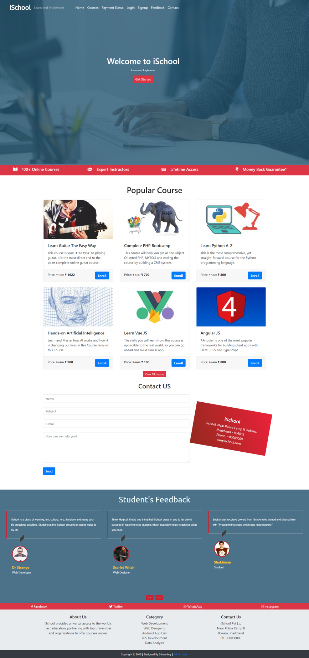
<?php
include('./dbConnection.php');
// Header Include from mainInclude
include('./mainInclude/header.php');
?>
<!-- Start Video Background-->
<div class="container-fluid remove-vid-marg">
<div class="vid-parent">
<video playsinline autoplay muted loop>
<source src="video/banvid.mp4" />
</video>
<div class="vid-overlay"></div>
</div>
<div class="vid-content" >
<h1 class="my-content">Welcome to iSchool</h1>
<small class="my-content">Learn and Implement</small><br />
<?php
if(!isset($_SESSION['is_login'])){
echo '<a class="btn btn-danger mt-3" href="#" data-toggle="modal" data-target="#stuRegModalCenter">Get Started</a>';
} else {
echo '<a class="btn btn-primary mt-3" href="student/studentProfile.php">My Profile</a>';
}
?>

</div>
</div> <!-- End Video Background -->

<div class="container-fluid bg-danger txt-banner"> <!-- Start Text Banner -->
<div class="row bottom-banner">
<div class="col-sm">
<h5> <i class="fas fa-book-open mr-3"></i> 100+ Online Courses</h5>
</div>
<div class="col-sm">
<h5><i class="fas fa-users mr-3"></i> Expert Instructors</h5>
</div>
<div class="col-sm">
<h5><i class="fas fa-keyboard mr-3"></i> Lifetime Access</h5>
</div>
<div class="col-sm">
<h5><i class="fas fa-rupee-sign mr-3"></i> Money Back Guarantee*</h5>
</div>
</div>
</div> <!-- End Text Banner -->

<div class="container mt-5"> <!-- Start Most Popular Course -->
<h1 class="text-center">Popular Course</h1>
<div class="card-deck mt-4"> <!-- Start Most Popular Course 1st Card Deck -->
<?php
$sql = "SELECT * FROM course LIMIT 3";
$result = $conn->query($sql);
if($result->num_rows > 0){
while($row = $result->fetch_assoc()){
$course_id = $row['course_id'];
echo '
<a href="coursedetails.php?course_id='.$course_id.'" class="btn" style="text-align: left; padding:0px; margin:0px;">
<div class="card">
<img src="'.str_replace('..', '.', $row['course_img']).'" class="card-img-top" alt="Guitar" />
<div class="card-body">
<h5 class="card-title">'.$row['course_name'].'</h5>
<p class="card-text">'.$row['course_desc'].'</p>
</div>
<div class="card-footer">
<p class="card-text d-inline">Price: <small><del>&#8377 '.$row['course_original_price'].'</del></small> <span class="font-weight-bolder">&#8377 '.$row['course_price'].'<span></p> <a class="btn btn-primary text-white font-weight-bolder float-right" href="coursedetails.php?course_id='.$course_id.'">Enroll</a>
</div>
</div>
</a> ';
}
}
?>
</div> <!-- End Most Popular Course 1st Card Deck -->
<div class="card-deck mt-4"> <!-- Start Most Popular Course 2nd Card Deck -->
<?php
$sql = "SELECT * FROM course LIMIT 3,3";
$result = $conn->query($sql);
if($result->num_rows > 0){
while($row = $result->fetch_assoc()){
$course_id = $row['course_id'];
echo '
<a href="coursedetails.php?course_id='.$course_id.'" class="btn" style="text-align: left; padding:0px;">
<div class="card">
<img src="'.str_replace('..', '.', $row['course_img']).'" class="card-img-top" alt="Guitar" />
<div class="card-body">
<h5 class="card-title">'.$row['course_name'].'</h5>
<p class="card-text">'.$row['course_desc'].'</p>
</div>
<div class="card-footer">
<p class="card-text d-inline">Price: <small><del>&#8377 '.$row['course_original_price'].'</del></small> <span class="font-weight-bolder">&#8377 '.$row['course_price'].'<span></p> <a class="btn btn-primary text-white font-weight-bolder float-right" href="#">Enroll</a>
</div>
</div>
</a> ';
}
}
?>
</div> <!-- End Most Popular Course 2nd Card Deck -->
<div class="text-center m-2">
<a class="btn btn-danger btn-sm" href="courses.php">View All Course</a>
</div>
</div> <!-- End Most Popular Course -->

<?php
// Contact Us
include('./contact.php');
?>

<!-- Start Students Testimonial -->
<div class="container-fluid mt-5" style="background-color: #4B7289" id="Feedback">
<h1 class="text-center testyheading p-4"> Student's Feedback </h1>
<div class="row">
<div class="col-md-12">
<div id="testimonial-slider" class="owl-carousel">
<?php
$sql = "SELECT s.stu_name, s.stu_occ, s.stu_img, f.f_content FROM student AS s JOIN feedback AS f ON s.stu_id = f.stu_id";
$result = $conn->query($sql);
if($result->num_rows > 0) {
while($row = $result->fetch_assoc()){
$s_img = $row['stu_img'];
$n_img = str_replace('../','',$s_img)
?>
<div class="testimonial">
<p class="description">
<?php echo $row['f_content'];?>
</p>
<div class="pic">
<img src="<?php echo $n_img; ?>" alt=""/>
</div>
<div class="testimonial-prof">
<h4><?php echo $row['stu_name']; ?></h4>
<small><?php echo $row['stu_occ']; ?></small>
</div>
</div>
<?php }} ?>
</div>
</div>
</div>
</div> <!-- End Students Testimonial -->

<div class="container-fluid bg-danger"> <!-- Start Social Follow -->
<div class="row text-white text-center p-1">
<div class="col-sm">
<a class="text-white social-hover" href="#"><i class="fab fa-facebook-f"></i> Facebook</a>
</div>
<div class="col-sm">
<a class="text-white social-hover" href="#"><i class="fab fa-twitter"></i> Twitter</a>
</div>
<div class="col-sm">
<a class="text-white social-hover" href="#"><i class="fab fa-whatsapp"></i> WhatsApp</a>
</div>
<div class="col-sm">
<a class="text-white social-hover" href="#"><i class="fab fa-instagram"></i> Instagram</a>
</div>
</div>
</div> <!-- End Social Follow -->

<!-- Start About Section -->
<div class="container-fluid p-4" style="background-color:#E9ECEF">
<div class="container" style="background-color:#E9ECEF">
<div class="row text-center">
<div class="col-sm">
<h5>About Us</h5>
<p>iSchool provides universal access to the world’s best education, partnering with top universities and organizations to offer courses online.</p>
</div>
<div class="col-sm">
<h5>Category</h5>
<a class="text-dark" href="#">Web Development</a><br />
<a class="text-dark" href="#">Web Designing</a><br />
<a class="text-dark" href="#">Android App Dev</a><br />
<a class="text-dark" href="#">iOS Development</a><br />
<a class="text-dark" href="#">Data Analysis</a><br />
</div>
<div class="col-sm">
<h5>Contact Us</h5>
<p>iSchool Pvt Ltd <br> Near Police Camp II <br> Bokaro, Jharkhand <br> Ph. 000000000 </p>
</div>
</div>
</div>
</div> <!-- End About Section -->

<?php
// Footer Include from mainInclude
include('./mainInclude/footer.php');

?>
courses.php



<?php
include('./dbConnection.php');
// Header Include from mainInclude
include('./mainInclude/header.php');
?>
<div class="container-fluid bg-dark"> <!-- Start Course Page Banner -->
<div class="row">
<img src="./image/coursebanner.jpg" alt="courses" style="height:500px; width:100%; object-fit:cover; box-shadow:10px;"/>
</div>
</div> <!-- End Course Page Banner -->

<div class="container mt-5"> <!-- Start All Course -->
<h1 class="text-center">All Courses</h1>
<div class="row mt-4"> <!-- Start All Course Row -->
<?php
$sql = "SELECT * FROM course";
$result = $conn->query($sql);
if($result->num_rows > 0){
while($row = $result->fetch_assoc()){
$course_id = $row['course_id'];
echo '
<div class="col-sm-4 mb-4">
<a href="coursedetails.php?course_id='.$course_id.'" class="btn" style="text-align: left; padding:0px;"><div class="card">
<img src="'.str_replace('..', '.', $row['course_img']).'" class="card-img-top" alt="Guitar" />
<div class="card-body">
<h5 class="card-title">'.$row['course_name'].'</h5>
<p class="card-text">'.$row['course_desc'].'</p>
</div>
<div class="card-footer">
<p class="card-text d-inline">Price: <small><del>&#8377 '.$row['course_original_price'].'</del></small> <span class="font-weight-bolder">&#8377 '.$row['course_price'].'<span></p> <a class="btn btn-primary text-white font-weight-bolder float-right" href="coursedetails.php?course_id='.$course_id.'">Enroll</a>
</div>
</div> </a>
</div>
';
}
}
?>
</div><!-- End All Course Row -->
</div><!-- End All Course -->

<?php
// Contact Us
include('./contact.php');
?>

<?php
// Footer Include from mainInclude
include('./mainInclude/footer.php');
?>

Coursedetails.php
<?php
include('./dbConnection.php');
// Header Include from mainInclude
include('./mainInclude/header.php');
?>
<div class="container-fluid bg-dark"> <!-- Start Course Page Banner -->
<div class="row">
<img src="./image/coursebanner.jpg" alt="courses" style="height:200px; width:100%; object-fit:cover; box-shadow:10px;"/>
</div>
</div> <!-- End Course Page Banner -->

<div class="container mt-5"> <!-- Start All Course -->
<?php
if(isset($_GET['course_id'])){
$course_id = $_GET['course_id'];
$_SESSION['course_id'] = $course_id;
$sql = "SELECT * FROM course WHERE course_id = '$course_id'";
$result = $conn->query($sql);
if($result->num_rows > 0){
while($row = $result->fetch_assoc()){
echo '
<div class="row">
<div class="col-md-4">
<img src="'.str_replace('..', '.', $row['course_img']).'" class="card-img-top" alt="Guitar" />
</div>
<div class="col-md-8">
<div class="card-body">
<h5 class="card-title">Course Name: '.$row['course_name'].'</h5>
<p class="card-text"> Description: '.$row['course_desc'].'</p>
<p class="card-text"> Duration: '.$row['course_duration'].'</p>
<form action="checkout.php" method="post">
<p class="card-text d-inline">Price: <small><del>&#8377 '.$row['course_original_price'].'</del></small> <span class="font-weight-bolder">&#8377 '.$row['course_price'].'<span></p>
<input type="hidden" name="id" value='. $row["course_price"] .'>
<button type="submit" class="btn btn-primary text-white font-weight-bolder float-right" name="buy">Buy Now</button>
</form>
</div>
</div>
';
}
}
}
?>
</div><!-- End All Course -->
<div class="container">
<div class="row">
<?php $sql = "SELECT * FROM lesson";
$result = $conn->query($sql);
if($result->num_rows > 0){
echo '
<table class="table table-bordered table-hover">
<thead>
<tr>
<th scope="col">Lesson No.</th>
<th scope="col">Lesson Name</th>
</tr>
</thead>
<tbody>';
$num = 0;
while($row = $result->fetch_assoc()){
if($row['course_id'] == $course_id) {
$num++;
echo ' <tr>
<th scope="row">'.$num.'</th>
<td>'. $row["lesson_name"].'</td></tr>';
}
}
echo '</tbody>
</table>';
} ?>
</div>
</div>
<?php
// Footer Include from mainInclude
include('./mainInclude/footer.php');
?>

Stustyle.css
.navbar-brand {
font-family: "Ubuntu", sans-serif;
font-size: 2em;
font-weight: bold;
color: #fff;
}
.active {
background-color: #225470;
color: #fff;
}

./stuInclude/header.php
<?php
include_once('../dbConnection.php');
if(!isset($_SESSION)){
session_start();
}
if(isset($_SESSION['is_login'])){
$stuLogEmail = $_SESSION['stuLogEmail'];
}
// else {
// echo "<script> location.href='../index.php'; </script>";
// }
if(isset($stuLogEmail)){
$sql = "SELECT stu_img FROM student WHERE stu_email = '$stuLogEmail'";
$result = $conn->query($sql);
$row = $result->fetch_assoc();
$stu_img = $row['stu_img'];
}
?>

<!DOCTYPE html>
<html lang="en">

<head>
<meta charset="UTF-8">
<meta name="viewport" content="width=device-width, initial-scale=1.0">
<meta http-equiv="X-UA-Compatible" content="ie=edge">
<title>
<?php echo TITLE ?>
</title>
<!-- Bootstrap CSS -->
<link rel="stylesheet" href="../css/bootstrap.min.css">

<!-- Font Awesome CSS -->
<link rel="stylesheet" href="../css/all.min.css">

<!-- Google Font -->
<link href="https://fonts.googleapis.com/css?family=Ubuntu" rel="stylesheet">

<!-- Custom CSS -->
<link rel="stylesheet" href="../css/stustyle.css">

</head>

<body>
<!-- Top Navbar -->
<nav class="navbar navbar-dark fixed-top flex-md-nowrap p-0 shadow" style="background-color: #225470;">
<a class="navbar-brand col-sm-3 col-md-2 mr-0" href="studentProfile.php">E-Learning</a>
</nav>

<!-- Side Bar -->
<div class="container-fluid mb-5 " style="margin-top:40px;">
<div class="row">
<nav class="col-sm-2 bg-light sidebar py-5 d-print-none">
<div class="sidebar-sticky">
<ul class="nav flex-column">
<li class="nav-item mb-3">
<img src="<?php echo $stu_img ?>" alt="studentimage" class="img-thumbnail rounded-circle">
</li>
<li class="nav-item">
<a class="nav-link <?php if(PAGE == 'profile') {echo 'active';} ?>" href="studentProfile.php">
<i class="fas fa-user"></i>
Profile <span class="sr-only">(current)</span>
</a>
</li>
<li class="nav-item">
<a class="nav-link <?php if(PAGE == 'mycourse') {echo 'active';} ?>" href="myCourse.php">
<i class="fab fa-accessible-icon"></i>
My Courses
</a>
</li>
<li class="nav-item">
<a class="nav-link <?php if(PAGE == 'feedback') {echo 'active';} ?>" href="stufeedback.php">
<i class="fab fa-accessible-icon"></i>
Feedback
</a>
</li>
<li class="nav-item">
<a class="nav-link <?php if(PAGE == 'studentChangePass') {echo 'active';} ?>" href="studentChangePass.php">
<i class="fas fa-key"></i>
Change Password
</a>
</li>
<li class="nav-item">
<a class="nav-link" href="../logout.php">
<i class="fas fa-sign-out-alt"></i>
Logout
</a>
</li>
</ul>
</div>
</nav>

./stuInclude/footer.php
<!-- Jquery and Boostrap JavaScript -->
<script type="text/javascript" src="../js/jquery.min.js"></script>
<script type="text/javascript" src="../js/popper.min.js"></script>
<script type="text/javascript" src="../js/bootstrap.min.js"></script>

<!-- Font Awesome JS -->
<script type="text/javascript" src="../js/all.min.js"></script>

<!-- Ajax Call JavaScript -->
<!-- <script type="text/javascript" src="..js/ajaxrequest.js"></script> -->

<!-- Custom JavaScript -->
<script type="text/javascript" src="../js/custom.js"></script>
</body>

</html>

Studentprofile.php
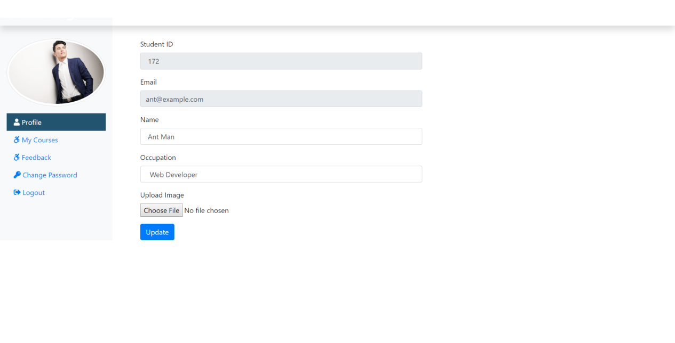
<?php
if(!isset($_SESSION)){
session_start();
}
define('TITLE', 'Student Profile');
define('PAGE', 'profile');
include('./stuInclude/header.php');
include_once('../dbConnection.php');

if(isset($_SESSION['is_login'])){
$stuEmail = $_SESSION['stuLogEmail'];
} else {
echo "<script> location.href='../index.php'; </script>";
}

$sql = "SELECT * FROM student WHERE stu_email='$stuEmail'";
$result = $conn->query($sql);
if($result->num_rows == 1){
$row = $result->fetch_assoc();
$stuId = $row["stu_id"];
$stuName = $row["stu_name"];
$stuOcc = $row["stu_occ"];
$stuImg = $row["stu_img"];

}

if(isset($_REQUEST['updateStuNameBtn'])){
if(($_REQUEST['stuName'] == "")){
// msg displayed if required field missing
$passmsg = '<div class="alert alert-warning col-sm-6 ml-5 mt-2" role="alert"> Fill All Fileds </div>';
} else {
$stuName = $_REQUEST["stuName"];
$stuOcc = $_REQUEST["stuOcc"];
$stu_image = $_FILES['stuImg']['name'];
$stu_image_temp = $_FILES['stuImg']['tmp_name'];
$img_folder = '../image/stu/'. $stu_image;
move_uploaded_file($stu_image_temp, $img_folder);
$sql = "UPDATE student SET stu_name = '$stuName', stu_occ = '$stuOcc', stu_img = '$img_folder' WHERE stu_email = '$stuEmail'";
if($conn->query($sql) == TRUE){
// below msg display on form submit success
$passmsg = '<div class="alert alert-success col-sm-6 ml-5 mt-2" role="alert"> Updated Successfully </div>';
} else {
// below msg display on form submit failed
$passmsg = '<div class="alert alert-danger col-sm-6 ml-5 mt-2" role="alert"> Unable to Update </div>';
}
}
}

?>
<div class="col-sm-6 mt-5">
<form class="mx-5" method="POST" enctype="multipart/form-data">
<div class="form-group">
<label for="stuId">Student ID</label>
<input type="text" class="form-control" id="stuId" name="stuId" value=" <?php if(isset($stuId)) {echo $stuId;} ?>" readonly>
</div>
<div class="form-group">
<label for="stuEmail">Email</label>
<input type="email" class="form-control" id="stuEmail" value=" <?php echo $stuEmail ?>" readonly>
</div>
<div class="form-group">
<label for="stuName">Name</label>
<input type="text" class="form-control" id="stuName" name="stuName" value=" <?php if(isset($stuName)) {echo $stuName;} ?>">
</div>
<div class="form-group">
<!-- Student doesnt mean school student it also means learner -->
<label for="stuOcc">Occupation</label>
<input type="text" class="form-control" id="stuOcc" name="stuOcc" value=" <?php if(isset($stuOcc)) {echo $stuOcc;} ?>">
</div>
<div class="form-group">
<label for="stuImg">Upload Image</label>
<input type="file" class="form-control-file" id="stuImg" name="stuImg">
</div>
<button type="submit" class="btn btn-primary" name="updateStuNameBtn">Update</button>
<?php if(isset($passmsg)) {echo $passmsg; } ?>
</form>
</div>

</div> <!-- Close Row Div from header file -->

<?php
include('./stuInclude/footer.php');
?>

Mycourse.php
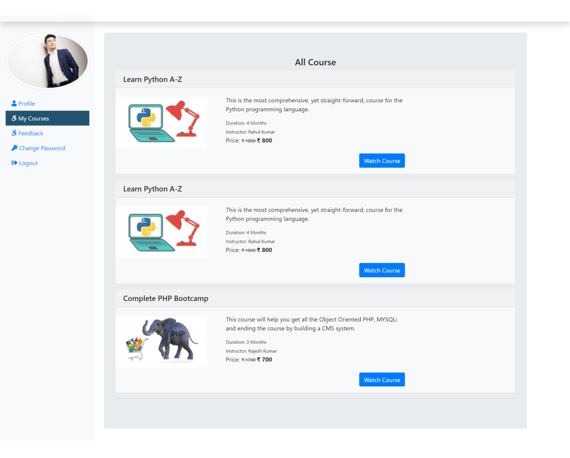
<?php
if(!isset($_SESSION)){
session_start();
}
define('TITLE', 'My Course');
define('PAGE', 'mycourse');
include('./stuInclude/header.php');
include_once('../dbConnection.php');

if(isset($_SESSION['is_login'])){
$stuLogEmail = $_SESSION['stuLogEmail'];
} else {
echo "<script> location.href='../index.php'; </script>";
}
?>

<div class="container mt-5 ml-4">
<div class="row">
<div class="jumbotron">
<h4 class="text-center">All Course</h4>
<?php
if(isset($stuLogEmail)){
$sql = "SELECT co.order_id, c.course_id, c.course_name, c.course_duration, c.course_desc, c.course_img, c.course_author, c.course_original_price, c.course_price FROM courseorder AS co JOIN course AS c ON c.course_id = co.course_id WHERE co.stu_email = '$stuLogEmail'";
$result = $conn->query($sql);
if($result->num_rows > 0) {
while($row = $result->fetch_assoc()){ ?>
<div class="bg-light mb-3">
<h5 class="card-header"><?php echo $row['course_name']; ?></h5>
<div class="row">

<div class="col-sm-3">
<img src="<?php echo $row['course_img']; ?>" class="card-img-top
mt-4" alt="pic">
</div>
<div class="col-sm-6 mb-3">
<div class="card-body">
<p class="card-title"><?php echo $row['course_desc']; ?></p>
<small class="card-text">Duration: <?php echo $row['course_duration']; ?></small><br />
<small class="card-text">Instructor: <?php echo $row['course_author']; ?></small><br/>
<p class="card-text d-inline">Price: <small><del>&#8377 <?php echo $row['course_original_price'] ?> </del></small> <span class="font-weight-bolder">&#8377 <?php echo $row['course_price']?> <span></p>
<a href="watchcourse.php?course_id=<?php echo $row['course_id'] ?>" class="btn btn-primary mt-5 float-right">Watch Course</a>
</div>
</div>

</div>

</div>
<?php
}
}
}

?>
<hr/>
</div>
</div>
</div>

</div> <!-- Close Row Div from header file -->
<?php
include('./stuInclude/footer.php');
?>

Stufeedback.php
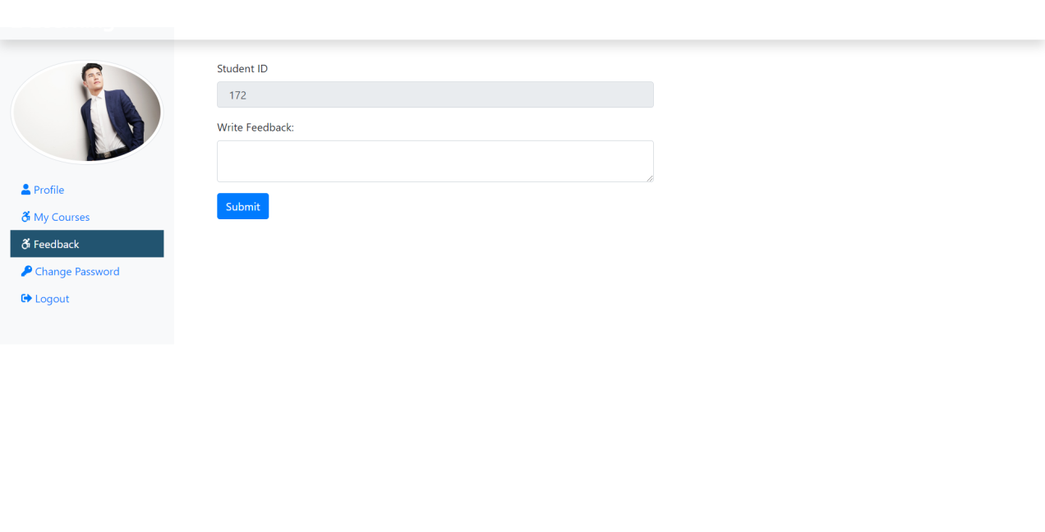
<?php
if(!isset($_SESSION)){
session_start();
}
define('TITLE', 'Feedback');
define('PAGE', 'feedback');
include('./stuInclude/header.php');
include_once('../dbConnection.php');

if(isset($_SESSION['is_login'])){
$stuEmail = $_SESSION['stuLogEmail'];
} else {
echo "<script> location.href='../index.php'; </script>";
}

$sql = "SELECT * FROM student WHERE stu_email='$stuEmail'";
$result = $conn->query($sql);
if($result->num_rows == 1){
$row = $result->fetch_assoc();
$stuId = $row["stu_id"];
}

if(isset($_REQUEST['submitFeedbackBtn'])){
if(($_REQUEST['f_content'] == "")){
// msg displayed if required field missing
$passmsg = '<div class="alert alert-warning col-sm-6 ml-5 mt-2" role="alert"> Fill All Fileds </div>';
} else {
$fcontent = $_REQUEST["f_content"];
$sql = "INSERT INTO feedback (f_content, stu_id) VALUES ('$fcontent', '$stuId')";
if($conn->query($sql) == TRUE){
// below msg display on form submit success
$passmsg = '<div class="alert alert-success col-sm-6 ml-5 mt-2" role="alert"> Submitted Successfully </div>';
} else {
// below msg display on form submit failed
$passmsg = '<div class="alert alert-danger col-sm-6 ml-5 mt-2" role="alert"> Unable to Submit </div>';
}
}
}

?>
<div class="col-sm-6 mt-5">
<form class="mx-5" method="POST" enctype="multipart/form-data">
<div class="form-group">
<label for="stuId">Student ID</label>
<input type="text" class="form-control" id="stuId" name="stuId" value=" <?php if(isset($stuId)) {echo $stuId;} ?>" readonly>
</div>
<div class="form-group">
<label for="f_content">Write Feedback:</label>
<textarea class="form-control" id="f_content" name="f_content" row=2></textarea>
</div>
<button type="submit" class="btn btn-primary" name="submitFeedbackBtn">Submit</button>
<?php if(isset($passmsg)) {echo $passmsg; } ?>
</form>
</div>

</div> <!-- Close Row Div from header file -->

<?php
include('./stuInclude/footer.php');
?>

studentChnagePass.php
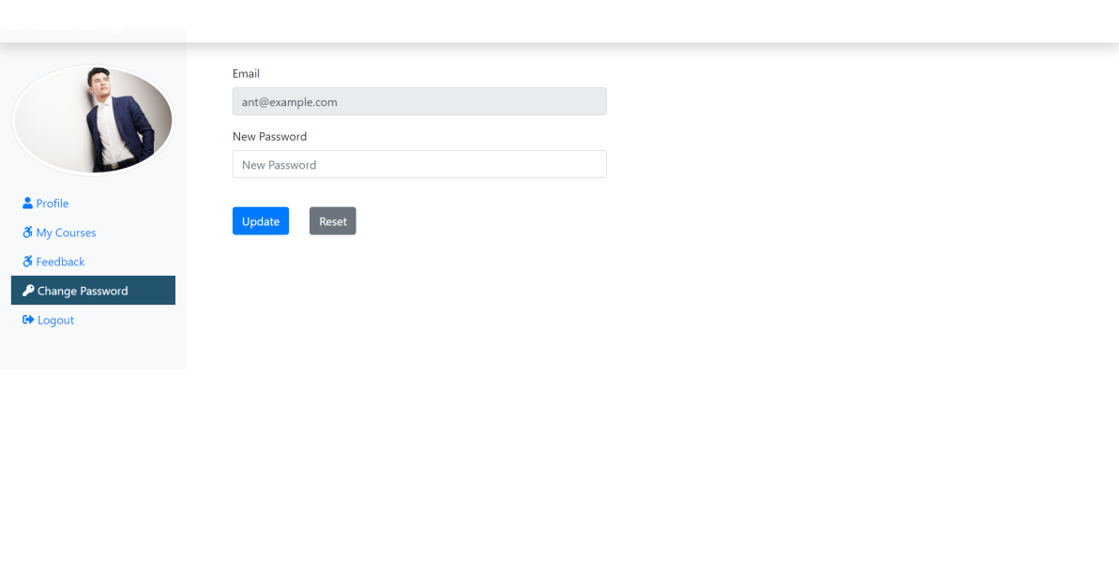
<?php
if(!isset($_SESSION)){
session_start();
}
define('TITLE', 'Change Password');
define('PAGE', 'studentChangePass');
include('./stuInclude/header.php');
include_once('../dbConnection.php');

if(isset($_SESSION['is_login'])){
$stuEmail = $_SESSION['stuLogEmail'];
} else {
echo "<script> location.href='../index.php'; </script>";
}

if(isset($_REQUEST['stuPassUpdateBtn'])){
if(($_REQUEST['stuNewPass'] == "")){
// msg displayed if required field missing
$passmsg = '<div class="alert alert-warning col-sm-6 ml-5 mt-2" role="alert"> Fill All Fileds </div>';
} else {
$sql = "SELECT * FROM student WHERE stu_email='$stuEmail'";
$result = $conn->query($sql);
if($result->num_rows == 1){
$stuPass = $_REQUEST['stuNewPass'];
$sql = "UPDATE student SET stu_pass = '$stuPass' WHERE stu_email = '$stuEmail'";
if($conn->query($sql) == TRUE){
// below msg display on form submit success
$passmsg = '<div class="alert alert-success col-sm-6 ml-5 mt-2" role="alert"> Updated Successfully </div>';
} else {
// below msg display on form submit failed
$passmsg = '<div class="alert alert-danger col-sm-6 ml-5 mt-2" role="alert"> Unable to Update </div>';
}
}
}
}

?>

<div class="col-sm-9 col-md-10">
<div class="row">
<div class="col-sm-6">
<form class="mt-5 mx-5" method="POST">
<div class="form-group">
<label for="inputEmail">Email</label>
<input type="email" class="form-control" id="inputEmail" value=" <?php echo $stuEmail ?>" readonly>
</div>
<div class="form-group">
<label for="inputnewpassword">New Password</label>
<input type="password" class="form-control" id="inputnewpassword" placeholder="New Password" name="stuNewPass">
</div>
<button type="submit" class="btn btn-primary mr-4 mt-4" name="stuPassUpdateBtn">Update</button>
<button type="reset" class="btn btn-secondary mt-4">Reset</button>
<?php if(isset($passmsg)) {echo $passmsg; } ?>
</form>

</div>

</div>
</div>

</div> <!-- Close Row Div from header file -->

<?php
include('./stuInclude/footer.php');
?>

adminstyle.css
.navbar-brand {
font-family: "Ubuntu", sans-serif;
font-size: 2em;
font-weight: bold;
color: #fff;
}

.active {
background-color: #225470;
color: #fff;
}

/* Plus Button for adding New Users Bottom Right */
.box {
position: fixed;
bottom: 10px;
right: 20px;
margin-bottom: 30px;
}

./adminInclude/header.php
<!DOCTYPE html>
<html lang="en">

<head>
<meta charset="UTF-8">
<meta name="viewport" content="width=device-width, initial-scale=1.0">
<meta http-equiv="X-UA-Compatible" content="ie=edge">
<title>
<?php echo TITLE ?>
</title>
<!-- Bootstrap CSS -->
<link rel="stylesheet" href="../css/bootstrap.min.css">

<!-- Font Awesome CSS -->
<link rel="stylesheet" href="../css/all.min.css">

<!-- Google Font -->
<link href="https://fonts.googleapis.com/css?family=Ubuntu" rel="stylesheet">

<!-- Custom CSS -->
<link rel="stylesheet" href="../css/adminstyle.css">

</head>

<body>
<!-- Top Navbar -->
<nav class="navbar navbar-dark fixed-top p-0 shadow" style="background-color: #225470;">
<a class="navbar-brand col-sm-3 col-md-2 mr-0" href="adminDashboard.php">E-Learning <small class="text-white">Admin Area</small></a>
</nav>

<!-- Side Bar -->
<div class="container-fluid mb-5" style="margin-top:40px;">
<div class="row">
<nav class="col-sm-3 col-md-2 bg-light sidebar py-5 d-print-none">
<div class="sidebar-sticky">
<ul class="nav flex-column">
<li class="nav-item">
<a class="nav-link <?php if(PAGE == 'dashboard') {echo 'active';} ?>" href="adminDashboard.php">
<i class="fas fa-tachometer-alt"></i>
Dashboard
</a>
</li>
<li class="nav-item">
<a class="nav-link <?php if(PAGE == 'courses') {echo 'active';} ?>" href="courses.php">
<i class="fab fa-accessible-icon"></i>
Courses
</a>
</li>
<li class="nav-item">
<a class="nav-link <?php if(PAGE == 'lessons') {echo 'active';} ?>" href="lessons.php">
<i class="fab fa-accessible-icon"></i>
Lessons
</a>
</li>
<li class="nav-item">
<a class="nav-link <?php if(PAGE == 'students') {echo 'active';} ?>" href="students.php">
<i class="fas fa-users"></i>
Students
</a>
</li>
<li class="nav-item">
<a class="nav-link <?php if(PAGE == 'sellreport') {echo 'active';} ?>" href="sellReport.php">
<i class="fas fa-table"></i>
Sell Report
</a>
</li>
<li class="nav-item">
<a class="nav-link <?php if(PAGE == 'paymentstatus') {echo 'active';} ?>" href="adminPaymentStatus.php">
<i class="fas fa-table"></i>
Payment Status
</a>
</li>
<li class="nav-item">
<a class="nav-link <?php if(PAGE == 'feedback') {echo 'active';} ?>" href="feedback.php">
<i class="fab fa-accessible-icon"></i>
Feedback
</a>
</li>
<li class="nav-item">
<a class="nav-link <?php if(PAGE == 'changepass') {echo 'active';} ?>" href="adminChangePass.php">
<i class="fas fa-key"></i>
Change Password
</a>
</li>
<li class="nav-item">
<a class="nav-link" href="../logout.php">
<i class="fas fa-sign-out-alt"></i>
Logout
</a>
</li>
</ul>
</div>
</nav>

./adminInclude/footer.php

<!-- Jquery and Boostrap JavaScript -->
<script type="text/javascript" src="../js/jquery.min.js"></script>
<script type="text/javascript" src="../js/popper.min.js"></script>
<script type="text/javascript" src="../js/bootstrap.min.js"></script>

<!-- Font Awesome JS -->
<script type="text/javascript" src="../js/all.min.js"></script>

<!-- Admin Ajax Call JavaScript -->
<script type="text/javascript" src="..js/adminajaxrequest.js"></script>

<!-- Custom JavaScript -->
<script type="text/javascript" src="../js/custom.js"></script>
</body>

</html>

Admindashboard.php

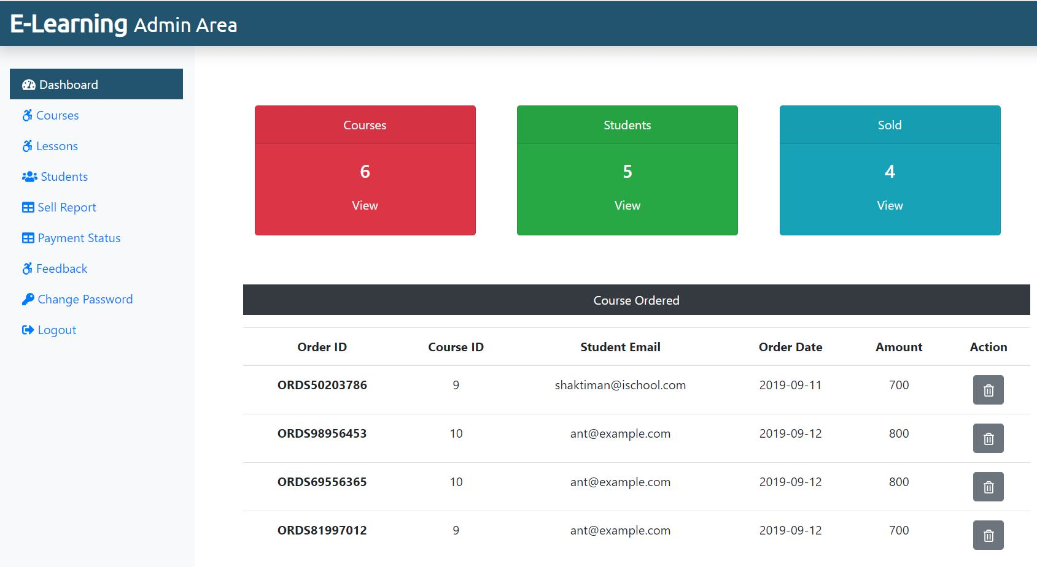

<?php
if(!isset($_SESSION)){
session_start();
}
define('TITLE', 'Dashboard');
define('PAGE', 'dashboard');
include('./adminInclude/header.php');
include('../dbConnection.php');

if(isset($_SESSION['is_admin_login'])){
$adminEmail = $_SESSION['adminLogEmail'];
} else {
echo "<script> location.href='../index.php'; </script>";
}
$sql = "SELECT * FROM course";
$result = $conn->query($sql);
$totalcourse = $result->num_rows;

$sql = "SELECT * FROM student";
$result = $conn->query($sql);
$totalstu = $result->num_rows;

$sql = "SELECT * FROM courseorder";
$result = $conn->query($sql);
$totalsold = $result->num_rows;
?>
<div class="col-sm-9 mt-5">
<div class="row mx-5 text-center">
<div class="col-sm-4 mt-5">
<div class="card text-white bg-danger mb-3" style="max-width: 18rem;">
<div class="card-header">Courses</div>
<div class="card-body">
<h4 class="card-title">
<?php echo $totalcourse; ?>
</h4>
<a class="btn text-white" href="courses.php">View</a>
</div>
</div>
</div>
<div class="col-sm-4 mt-5">
<div class="card text-white bg-success mb-3" style="max-width: 18rem;">
<div class="card-header">Students</div>
<div class="card-body">
<h4 class="card-title">
<?php echo $totalstu; ?>
</h4>
<a class="btn text-white" href="students.php">View</a>
</div>
</div>
</div>
<div class="col-sm-4 mt-5">
<div class="card text-white bg-info mb-3" style="max-width: 18rem;">
<div class="card-header">Sold</div>
<div class="card-body">
<h4 class="card-title">
<?php echo $totalsold; ?>
</h4>
<a class="btn text-white" href="sellreport.php">View</a>
</div>
</div>
</div>
</div>
<div class="mx-5 mt-5 text-center">
<!--Table-->
<p class=" bg-dark text-white p-2">Course Ordered</p>
<?php
$sql = "SELECT * FROM courseorder";
$result = $conn->query($sql);
if($result->num_rows > 0){
echo '<table class="table">
<thead>
<tr>
<th scope="col">Order ID</th>
<th scope="col">Course ID</th>
<th scope="col">Student Email</th>
<th scope="col">Order Date</th>
<th scope="col">Amount</th>
<th scope="col">Action</th>
</tr>
</thead>
<tbody>';
while($row = $result->fetch_assoc()){
echo '<tr>';
echo '<th scope="row">'.$row["order_id"].'</th>';
echo '<td>'. $row["course_id"].'</td>';
echo '<td>'.$row["stu_email"].'</td>';
echo '<td>'.$row["order_date"].'</td>';
echo '<td>'.$row["amount"].'</td>';
echo '<td><form action="" method="POST" class="d-inline"><input type="hidden" name="id" value='. $row["co_id"] .'><button type="submit" class="btn btn-secondary" name="delete" value="Delete"><i class="far fa-trash-alt"></i></button></form></td>';
echo '</tr>';
}
echo '</tbody>
</table>';
} else {
echo "0 Result";
}
if(isset($_REQUEST['delete'])){
$sql = "DELETE FROM courseorder WHERE co_id = {$_REQUEST['id']}";
if($conn->query($sql) === TRUE){
// echo "Record Deleted Successfully";
// below code will refresh the page after deleting the record
echo '<meta http-equiv="refresh" content= "0;URL=?deleted" />';
} else {
echo "Unable to Delete Data";
}
}
?>
</div>
</div>
</div>
</div>

</div> <!-- div Row close from header -->
</div> <!-- div Conatiner-fluid close from header -->
<?php
include('./adminInclude/footer.php');
?>

Courses.php

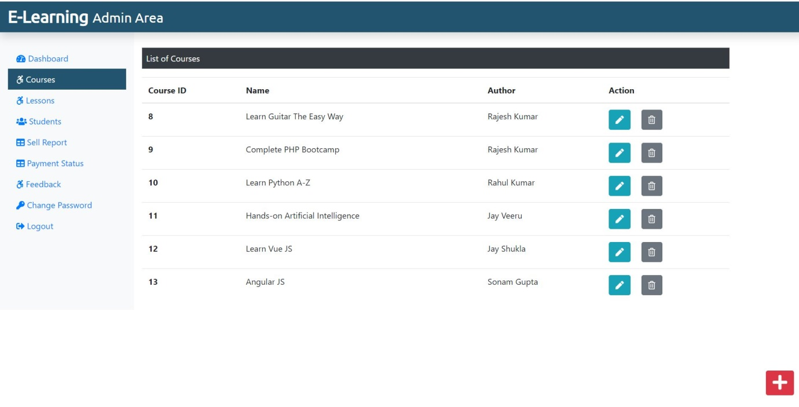
<?php
if(!isset($_SESSION)){
session_start();
}
define('TITLE', 'Courses');
define('PAGE', 'courses');
include('./adminInclude/header.php');
include('../dbConnection.php');

if(isset($_SESSION['is_admin_login'])){
$adminEmail = $_SESSION['adminLogEmail'];
} else {
echo "<script> location.href='../index.php'; </script>";
}
?>

<div class="col-sm-9 mt-5">
<!--Table-->
<p class=" bg-dark text-white p-2">List of Courses</p>
<?php
$sql = "SELECT * FROM course";
$result = $conn->query($sql);
if($result->num_rows > 0){
echo '<table class="table">
<thead>
<tr>
<th scope="col">Course ID</th>
<th scope="col">Name</th>
<th scope="col">Author</th>
<th scope="col">Action</th>
</tr>
</thead>
<tbody>';
while($row = $result->fetch_assoc()){
echo '<tr>';
echo '<th scope="row">'.$row["course_id"].'</th>';
echo '<td>'. $row["course_name"].'</td>';
echo '<td>'.$row["course_author"].'</td>';
echo '<td><form action="editcourse.php" method="POST" class="d-inline"> <input type="hidden" name="id" value='. $row["course_id"] .'><button type="submit" class="btn btn-info mr-3" name="view" value="View"><i class="fas fa-pen"></i></button></form>
<form action="" method="POST" class="d-inline"><input type="hidden" name="id" value='. $row["course_id"] .'><button type="submit" class="btn btn-secondary" name="delete" value="Delete"><i class="far fa-trash-alt"></i></button></form></td>
</tr>';
}

echo '</tbody>
</table>';
} else {
echo "0 Result";
}
if(isset($_REQUEST['delete'])){
$sql = "DELETE FROM course WHERE course_id = {$_REQUEST['id']}";
if($conn->query($sql) === TRUE){
// echo "Record Deleted Successfully";
// below code will refresh the page after deleting the record
echo '<meta http-equiv="refresh" content= "0;URL=?deleted" />';
} else {
echo "Unable to Delete Data";
}
}
?>
</div>
</div> <!-- div Row close from header -->
<div><a class="btn btn-danger box" href="./addCourse.php"><i class="fas fa-plus fa-2x"></i></a></div>
</div> <!-- div Conatiner-fluid close from header -->
<?php
include('./adminInclude/footer.php');
?>

Addcourse.php

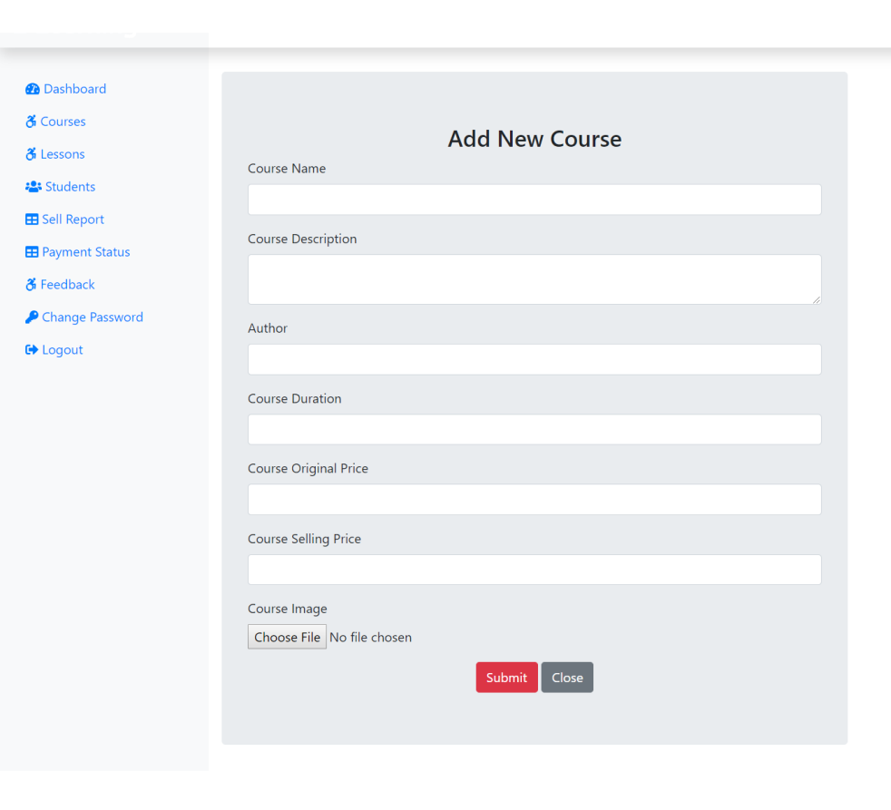

<?php
if(!isset($_SESSION)){
session_start();
}
define('TITLE', 'Add Course');
include('./adminInclude/header.php');
include('../dbConnection.php');

if(isset($_SESSION['is_admin_login'])){
$adminEmail = $_SESSION['adminLogEmail'];
} else {
echo "<script> location.href='../index.php'; </script>";
}
if(isset($_REQUEST['courseSubmitBtn'])){
// Checking for Empty Fields
if(($_REQUEST['course_name'] == "") || ($_REQUEST['course_desc'] == "") || ($_REQUEST['course_author'] == "") || ($_REQUEST['course_duration'] == "") || ($_REQUEST['course_price'] == "") || ($_REQUEST['course_original_price'] == "")){
// msg displayed if required field missing
$msg = '<div class="alert alert-warning col-sm-6 ml-5 mt-2" role="alert"> Fill All Fileds </div>';
} else {
// Assigning User Values to Variable
$course_name = $_REQUEST['course_name'];
$course_desc = $_REQUEST['course_desc'];
$course_author = $_REQUEST['course_author'];
$course_duration = $_REQUEST['course_duration'];
$course_price = $_REQUEST['course_price'];
$course_original_price = $_REQUEST['course_original_price'];
$course_image = $_FILES['course_img']['name'];
$course_image_temp = $_FILES['course_img']['tmp_name'];
$img_folder = '../image/courseimg/'. $course_image;
move_uploaded_file($course_image_temp, $img_folder);
$sql = "INSERT INTO course (course_name, course_desc, course_author, course_img, course_duration, course_price, course_original_price) VALUES ('$course_name', '$course_desc','$course_author', '$img_folder', '$course_duration', '$course_price', '$course_original_price')";
if($conn->query($sql) == TRUE){
// below msg display on form submit success
$msg = '<div class="alert alert-success col-sm-6 ml-5 mt-2" role="alert"> Course Added Successfully </div>';
} else {
// below msg display on form submit failed
$msg = '<div class="alert alert-danger col-sm-6 ml-5 mt-2" role="alert"> Unable to Add Course </div>';
}
}
}
?>
<div class="col-sm-6 mt-5 mx-3 jumbotron">
<h3 class="text-center">Add New Course</h3>
<form action="" method="POST" enctype="multipart/form-data">
<div class="form-group">
<label for="course_name">Course Name</label>
<input type="text" class="form-control" id="course_name" name="course_name">
</div>
<div class="form-group">
<label for="course_desc">Course Description</label>
<textarea class="form-control" id="course_desc" name="course_desc" row=2></textarea>
</div>
<div class="form-group">
<label for="course_author">Author</label>
<input type="text" class="form-control" id="course_author" name="course_author">
</div>
<div class="form-group">
<label for="course_duration">Course Duration</label>
<input type="text" class="form-control" id="course_duration" name="course_duration">
</div>
<div class="form-group">
<label for="course_original_price">Course Original Price</label>
<input type="text" class="form-control" id="course_original_price" name="course_original_price" onkeypress="isInputNumber(event)">
</div>
<div class="form-group">
<label for="course_price">Course Selling Price</label>
<input type="text" class="form-control" id="course_price" name="course_price" onkeypress="isInputNumber(event)">
</div>
<div class="form-group">
<label for="course_img">Course Image</label>
<input type="file" class="form-control-file" id="course_img" name="course_img">
</div>
<div class="text-center">
<button type="submit" class="btn btn-danger" id="courseSubmitBtn" name="courseSubmitBtn">Submit</button>
<a href="courses.php" class="btn btn-secondary">Close</a>
</div>
<?php if(isset($msg)) {echo $msg; } ?>
</form>
</div>
<!-- Only Number for input fields -->
<script>
function isInputNumber(evt) {
var ch = String.fromCharCode(evt.which);
if (!(/[0-9]/.test(ch))) {
evt.preventDefault();
}
}
</script>
</div> <!-- div Row close from header -->
</div> <!-- div Conatiner-fluid close from header -->

<?php
include('./adminInclude/footer.php');
?>

Editcourse.php
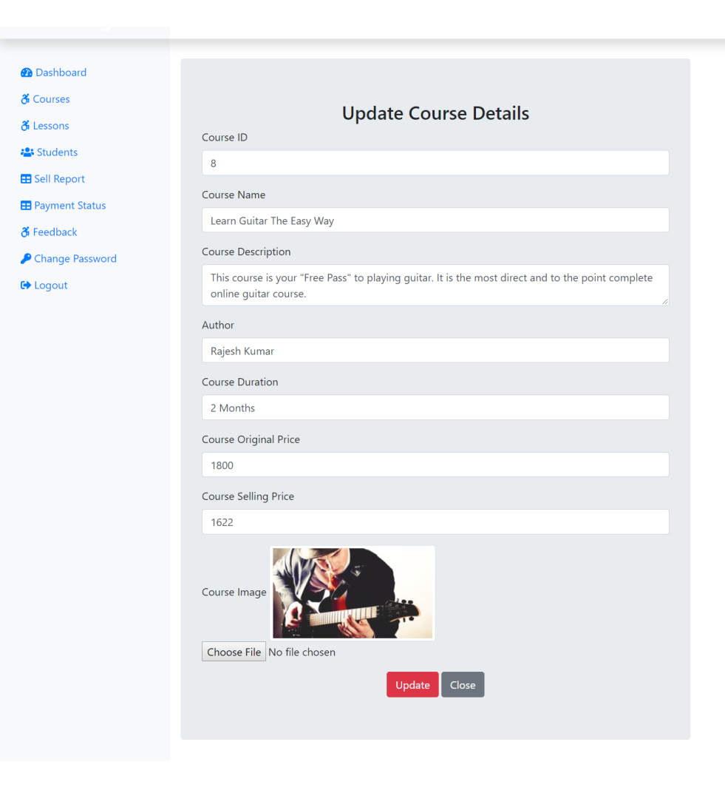

<?php
if(!isset($_SESSION)){
session_start();
}
define('TITLE', 'Edit Course');
include('./adminInclude/header.php');
include('../dbConnection.php');

if(isset($_SESSION['is_admin_login'])){
$adminEmail = $_SESSION['adminLogEmail'];
}
else {
echo "<script> location.href='../index.php'; </script>";
}
// Update
if(isset($_REQUEST['requpdate'])){
// Checking for Empty Fields
if(($_REQUEST['course_id'] == "") || ($_REQUEST['course_name'] == "") || ($_REQUEST['course_desc'] == "") || ($_REQUEST['course_author'] == "") || ($_REQUEST['course_duration'] == "") || ($_REQUEST['course_price'] == "") || ($_REQUEST['course_original_price'] == "")){
// msg displayed if required field missing
$msg = '<div class="alert alert-warning col-sm-6 ml-5 mt-2" role="alert"> Fill All Fileds </div>';
} else {
// Assigning User Values to Variable
$cid = $_REQUEST['course_id'];
$cname = $_REQUEST['course_name'];
$cdesc = $_REQUEST['course_desc'];
$cauthor = $_REQUEST['course_author'];
$cduration = $_REQUEST['course_duration'];
$cprice = $_REQUEST['course_price'];
$coriginalprice = $_REQUEST['course_original_price'];
$cimg = '../image/courseimg/'. $_FILES['course_img']['name'];

$sql = "UPDATE course SET course_id = '$cid', course_name = '$cname', course_desc = '$cdesc', course_author='$cauthor', course_duration='$cduration', course_price='$cprice', course_original_price='$coriginalprice', course_img='$cimg' WHERE course_id = '$cid'";
if($conn->query($sql) == TRUE){
// below msg display on form submit success
$msg = '<div class="alert alert-success col-sm-6 ml-5 mt-2" role="alert"> Updated Successfully </div>';
} else {
// below msg display on form submit failed
$msg = '<div class="alert alert-danger col-sm-6 ml-5 mt-2" role="alert"> Unable to Update </div>';
}
}
}
?>
<div class="col-sm-6 mt-5 mx-3 jumbotron">
<h3 class="text-center">Update Course Details</h3>
<?php
if(isset($_REQUEST['view'])){
$sql = "SELECT * FROM course WHERE course_id = {$_REQUEST['id']}";
$result = $conn->query($sql);
$row = $result->fetch_assoc();
}
?>
<form action="" method="POST" enctype="multipart/form-data">
<div class="form-group">
<label for="course_id">Course ID</label>
<input type="text" class="form-control" id="course_id" name="course_id" value="<?php if(isset($row['course_id'])) {echo $row['course_id']; }?>" readonly>
</div>
<div class="form-group">
<label for="course_name">Course Name</label>
<input type="text" class="form-control" id="course_name" name="course_name" value="<?php if(isset($row['course_name'])) {echo $row['course_name']; }?>">
</div>

<div class="form-group">
<label for="course_desc">Course Description</label>
<textarea class="form-control" id="course_desc" name="course_desc" row=2><?php if(isset($row['course_desc'])) {echo $row['course_desc']; }?></textarea>
</div>
<div class="form-group">
<label for="course_author">Author</label>
<input type="text" class="form-control" id="course_author" name="course_author" value="<?php if(isset($row['course_author'])) {echo $row['course_author']; }?>">
</div>
<div class="form-group">
<label for="course_duration">Course Duration</label>
<input type="text" class="form-control" id="course_duration" name="course_duration" value="<?php if(isset($row['course_duration'])) {echo $row['course_duration']; }?>">
</div>
<div class="form-group">
<label for="course_original_price">Course Original Price</label>
<input type="text" class="form-control" id="course_original_price" name="course_original_price" onkeypress="isInputNumber(event)" value="<?php if(isset($row['course_original_price'])) {echo $row['course_original_price']; }?>">
</div>
<div class="form-group">
<label for="course_price">Course Selling Price</label>
<input type="text" class="form-control" id="course_price" name="course_price" onkeypress="isInputNumber(event)" value="<?php if(isset($row['course_price'])) {echo $row['course_price']; }?>">
</div>
<div class="form-group">
<label for="course_img">Course Image</label>
<img src="<?php if(isset($row['course_img'])) {echo $row['course_img']; }?>" alt="courseimage" class="img-thumbnail">
<input type="file" class="form-control-file" id="course_img" name="course_img">
</div>

<div class="text-center">
<button type="submit" class="btn btn-danger" id="requpdate" name="requpdate">Update</button>
<a href="courses.php" class="btn btn-secondary">Close</a>
</div>
<?php if(isset($msg)) {echo $msg; } ?>
</form>
</div>
</div> <!-- div Row close from header -->
</div> <!-- div Conatiner-fluid close from header -->

<?php
include('./adminInclude/footer.php');
?>

Lessons.php

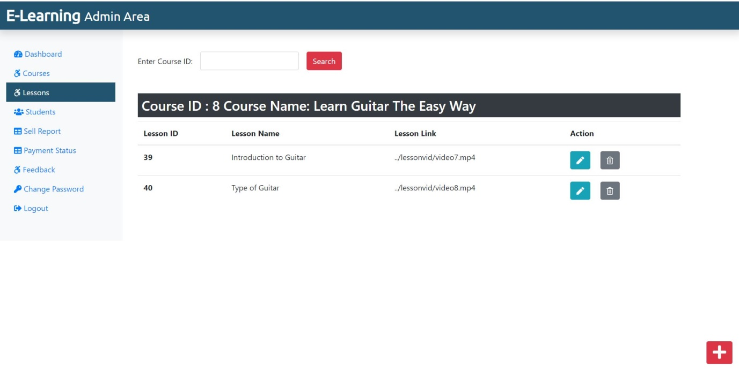
<?php
if(!isset($_SESSION)){
session_start();
}
define('TITLE', 'Lessons');
define('PAGE', 'lessons');
include('./adminInclude/header.php');
include('../dbConnection.php');

if(isset($_SESSION['is_admin_login'])){
$adminEmail = $_SESSION['adminLogEmail'];
} else {
echo "<script> location.href='../index.php'; </script>";
}
?>

<div class="col-sm-9 mt-5 mx-3">
<form action="" class="mt-3 form-inline d-print-none">
<div class="form-group mr-3">
<label for="checkid">Enter Course ID: </label>
<input type="text" class="form-control ml-3" id="checkid" name="checkid" onkeypress="isInputNumber(event)">
</div>
<button type="submit" class="btn btn-danger">Search</button>
</form>
<?php
$sql = "SELECT course_id FROM course";
$result = $conn->query($sql);
while($row = $result->fetch_assoc()){
if(isset($_REQUEST['checkid']) && $_REQUEST['checkid'] == $row['course_id']){
$sql = "SELECT * FROM course WHERE course_id = {$_REQUEST['checkid']}";
$result = $conn->query($sql);
$row = $result->fetch_assoc();
if(($row['course_id']) == $_REQUEST['checkid']){
$_SESSION['course_id'] = $row['course_id'];
$_SESSION['course_name'] = $row['course_name'];

?>
<h3 class="mt-5 bg-dark text-white p-2">Course ID : <?php if(isset($row['course_id'])) {echo $row['course_id']; } ?> Course Name: <?php if(isset($row['course_name'])) {echo $row['course_name']; } ?></h3>
<?php
$sql = "SELECT * FROM lesson WHERE course_id = {$_REQUEST['checkid']}";
$result = $conn->query($sql);
echo '<table class="table">
<thead>
<tr>
<th scope="col">Lesson ID</th>
<th scope="col">Lesson Name</th>
<th scope="col">Lesson Link</th>
<th scope="col">Action</th>
</tr>
</thead>
<tbody>';
while($row = $result->fetch_assoc()){
echo '<tr>';
echo '<th scope="row">'.$row["lesson_id"].'</th>';
echo '<td>'. $row["lesson_name"].'</td>';
echo '<td>'.$row["lesson_link"].'</td>';
echo '<td><form action="editlesson.php" method="POST" class="d-inline"> <input type="hidden" name="id" value='. $row["lesson_id"] .'><button type="submit" class="btn btn-info mr-3" name="view" value="View"><i class="fas fa-pen"></i></button></form>
<form action="" method="POST" class="d-inline"><input type="hidden" name="id" value='. $row["lesson_id"] .'><button type="submit" class="btn btn-secondary" name="delete" value="Delete"><i class="far fa-trash-alt"></i></button></form></td>
</tr>';
}
echo '</tbody>
</table>';
} else {
echo '<div class="alert alert-dark mt-4" role="alert">
Course Not Found ! </div>';
}
if(isset($_REQUEST['delete'])){
$sql = "DELETE FROM lesson WHERE lesson_id = {$_REQUEST['id']}";
if($conn->query($sql) === TRUE){
// echo "Record Deleted Successfully";
// below code will refresh the page after deleting the record
echo '<meta http-equiv="refresh" content= "0;URL=?deleted" />';
} else {
echo "Unable to Delete Data";
}
}
}
}?>

</div>
<!-- Only Number for input fields -->
<script>
function isInputNumber(evt) {
var ch = String.fromCharCode(evt.which);
if (!(/[0-9]/.test(ch))) {
evt.preventDefault();
}
}
</script>
</div> <!-- div Row close from header -->
<?php if(isset($_SESSION['course_id'])){
echo '<div><a class="btn btn-danger box" href="./addLesson.php"><i class="fas fa-plus fa-2x"></i></a></div>';
} ?>

</div> <!-- div Conatiner-fluid close from header -->
<?php
include('./adminInclude/footer.php');
?>

Addlesson.php
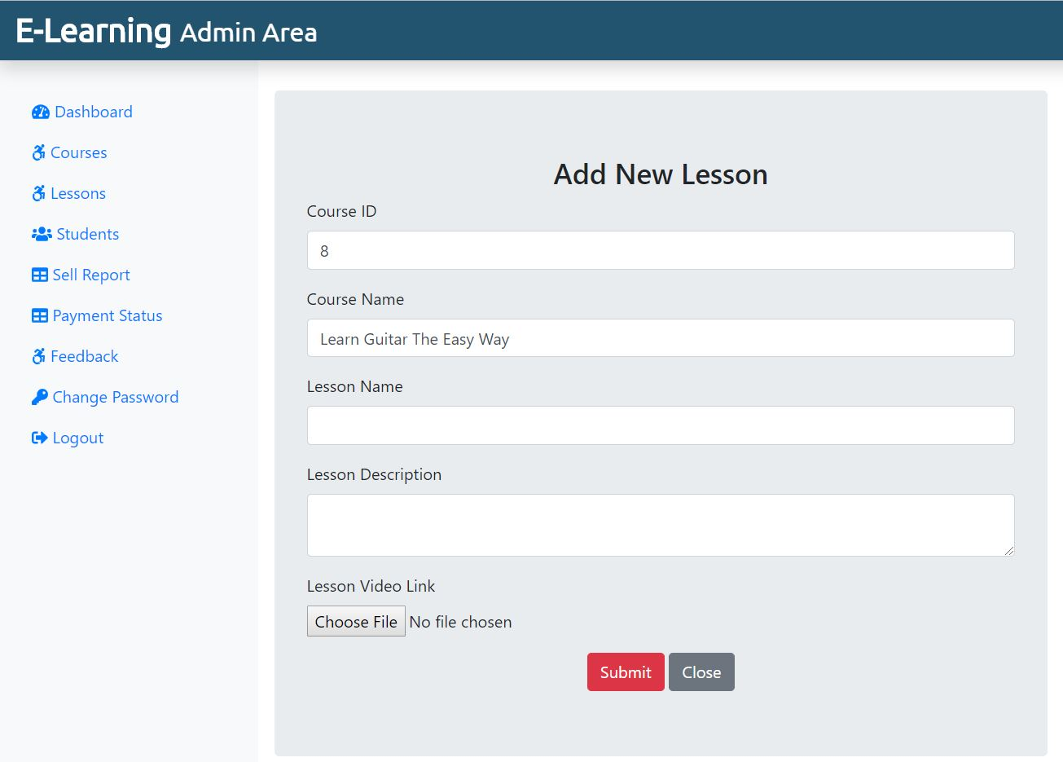
<?php
if(!isset($_SESSION)){
session_start();
}
define('TITLE', 'Add Lesson');
include('./adminInclude/header.php');
include('../dbConnection.php');

if(isset($_SESSION['is_admin_login'])){
$adminEmail = $_SESSION['adminLogEmail'];
} else {
echo "<script> location.href='../index.php'; </script>";
}
if(isset($_REQUEST['lessonSubmitBtn'])){
// Checking for Empty Fields
if(($_REQUEST['lesson_name'] == "") || ($_REQUEST['lesson_desc'] == "") || ($_REQUEST['course_id'] == "") || ($_REQUEST['course_name'] == "")){
// msg displayed if required field missing
$msg = '<div class="alert alert-warning col-sm-6 ml-5 mt-2" role="alert"> Fill All Fileds </div>';
} else {
// Assigning User Values to Variable
$lesson_name = $_REQUEST['lesson_name'];
$lesson_desc = $_REQUEST['lesson_desc'];
$course_id = $_REQUEST['course_id'];
$course_name = $_REQUEST['course_name'];
$lesson_link = $_FILES['lesson_link']['name'];
$lesson_link_temp = $_FILES['lesson_link']['tmp_name'];
$link_folder = '../lessonvid/'.$lesson_link;
move_uploaded_file($lesson_link_temp, $link_folder);
$sql = "INSERT INTO lesson (lesson_name, lesson_desc, lesson_link, course_id, course_name) VALUES ('$lesson_name', '$lesson_desc','$link_folder', '$course_id', '$course_name')";
if($conn->query($sql) == TRUE){
// below msg display on form submit success
$msg = '<div class="alert alert-success col-sm-6 ml-5 mt-2" role="alert"> Lesson Added Successfully </div>';
} else {
// below msg display on form submit failed
$msg = '<div class="alert alert-danger col-sm-6 ml-5 mt-2" role="alert"> Unable to Add Lesson </div>';
}
}
}
?>
<div class="col-sm-6 mt-5 mx-3 jumbotron">
<h3 class="text-center">Add New Lesson</h3>
<form action="" method="POST" enctype="multipart/form-data">
<div class="form-group">
<label for="course_id">Course ID</label>
<input type="text" class="form-control" id="course_id" name="course_id" value ="<?php if(isset($_SESSION['course_id'])){echo $_SESSION['course_id'];} ?>" readonly>
</div>
<div class="form-group">
<label for="course_name">Course Name</label>
<input type="text" class="form-control" id="course_name" name="course_name" value ="<?php if(isset($_SESSION['course_name'])){echo $_SESSION['course_name'];} ?>" readonly>
</div>
<div class="form-group">
<label for="lesson_name">Lesson Name</label>
<input type="text" class="form-control" id="lesson_name" name="lesson_name">
</div>
<div class="form-group">
<label for="lesson_desc">Lesson Description</label>
<textarea class="form-control" id="lesson_desc" name="lesson_desc" row=2></textarea>
</div>
<div class="form-group">
<label for="lesson_link">Lesson Video Link</label>
<input type="file" class="form-control-file" id="lesson_link" name="lesson_link">
</div>
<div class="text-center">
<button type="submit" class="btn btn-danger" id="lessonSubmitBtn" name="lessonSubmitBtn">Submit</button>
<a href="lessons.php" class="btn btn-secondary">Close</a>
</div>
<?php if(isset($msg)) {echo $msg; } ?>
</form>
</div>
<!-- Only Number for input fields -->
<script>
function isInputNumber(evt) {
var ch = String.fromCharCode(evt.which);
if (!(/[0-9]/.test(ch))) {
evt.preventDefault();
}
}

</script>
</div> <!-- div Row close from header -->
</div> <!-- div Conatiner-fluid close from header -->

<?php
include('./adminInclude/footer.php');
?>

Editlesson.php

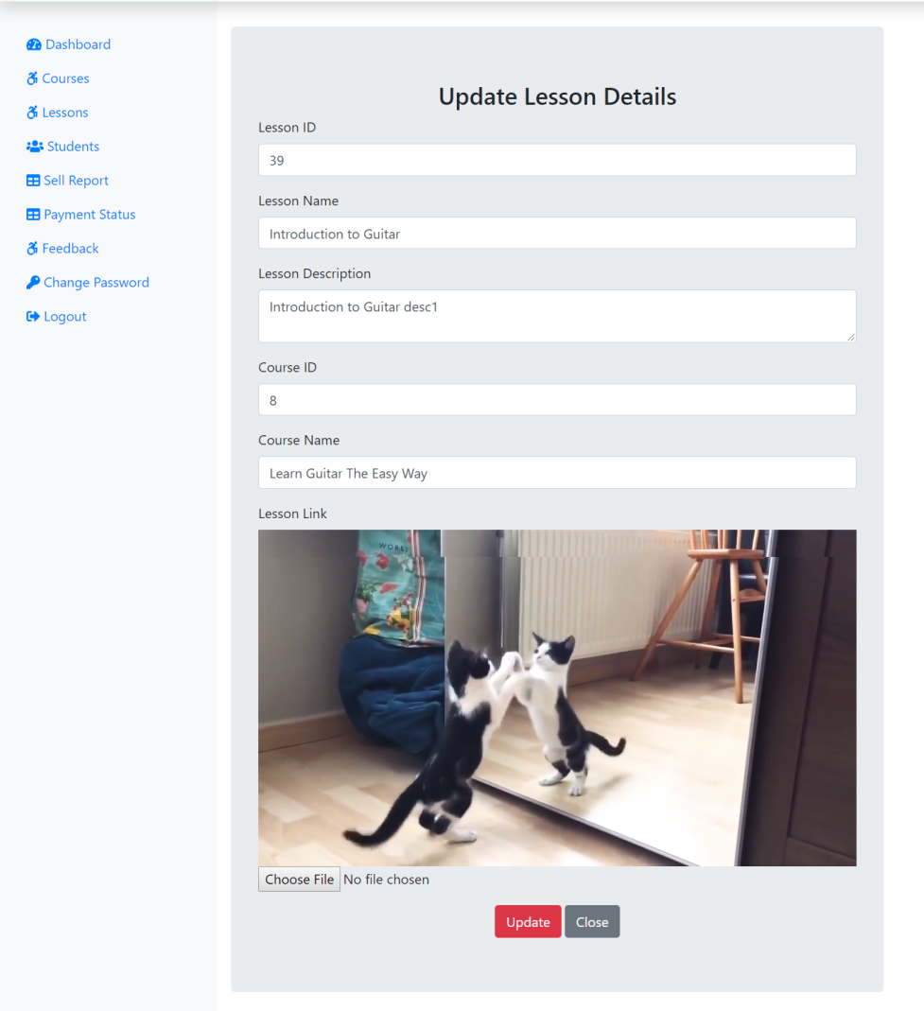
<?php
if(!isset($_SESSION)){
session_start();
}
define('TITLE', 'Edit Lesson');
include('./adminInclude/header.php');
include('../dbConnection.php');

if(isset($_SESSION['is_admin_login'])){
$adminEmail = $_SESSION['adminLogEmail'];
} else {
echo "<script> location.href='../index.php'; </script>";
}
// Update
if(isset($_REQUEST['requpdate'])){
// Checking for Empty Fields
if(($_REQUEST['lesson_id'] == "") || ($_REQUEST['lesson_name'] == "") || ($_REQUEST['lesson_desc'] == "") || ($_REQUEST['course_id'] == "") || ($_REQUEST['course_name'] == "")){
// msg displayed if required field missing
$msg = '<div class="alert alert-warning col-sm-6 ml-5 mt-2" role="alert"> Fill All Fileds </div>';
} else {
// Assigning User Values to Variable
$lid = $_REQUEST['lesson_id'];
$lname = $_REQUEST['lesson_name'];
$ldesc = $_REQUEST['lesson_desc'];
$cid = $_REQUEST['course_id'];
$cname = $_REQUEST['course_name'];
$llink = '../lessonvid/'. $_FILES['lesson_link']['name'];

$sql = "UPDATE lesson SET lesson_id = '$lid', lesson_name = '$lname', lesson_desc = '$ldesc', course_id='$cid', course_name='$cname', lesson_link='$llink' WHERE lesson_id = '$lid'";
if($conn->query($sql) == TRUE){
// below msg display on form submit success
$msg = '<div class="alert alert-success col-sm-6 ml-5 mt-2" role="alert"> Updated Successfully </div>';
} else {
// below msg display on form submit failed
$msg = '<div class="alert alert-danger col-sm-6 ml-5 mt-2" role="alert"> Unable to Update </div>';
}
}
}
?>
<div class="col-sm-6 mt-5 mx-3 jumbotron">
<h3 class="text-center">Update Lesson Details</h3>
<?php
if(isset($_REQUEST['view'])){
$sql = "SELECT * FROM lesson WHERE lesson_id = {$_REQUEST['id']}";
$result = $conn->query($sql);
$row = $result->fetch_assoc();
}
?>
<form action="" method="POST" enctype="multipart/form-data">
<div class="form-group">
<label for="lesson_id">Lesson ID</label>
<input type="text" class="form-control" id="lesson_id" name="lesson_id" value="<?php if(isset($row['lesson_id'])) {echo $row['lesson_id']; }?>" readonly>
</div>
<div class="form-group">
<label for="lesson_name">Lesson Name</label>
<input type="text" class="form-control" id="lesson_name" name="lesson_name" value="<?php if(isset($row['lesson_name'])) {echo $row['lesson_name']; }?>">
</div>

<div class="form-group">
<label for="lesson_desc">Lesson Description</label>
<textarea class="form-control" id="lesson_desc" name="lesson_desc" row=2><?php if(isset($row['lesson_desc'])) {echo $row['lesson_desc']; }?></textarea>
</div>
<div class="form-group">
<label for="course_id">Course ID</label>
<input type="text" class="form-control" id="course_id" name="course_id" value="<?php if(isset($row['course_id'])) {echo $row['course_id']; }?>" readonly>
</div>
<div class="form-group">
<label for="course_name">Course Name</label>
<input type="text" class="form-control" id="course_name" name="course_name" onkeypress="isInputNumber(event)" value="<?php if(isset($row['course_name'])) {echo $row['course_name']; }?>" readonly>
</div>
<div class="form-group">
<label for="lesson_link">Lesson Link</label>
<div class="embed-responsive embed-responsive-16by9">
<iframe class="embed-responsive-item" src="<?php if(isset($row['lesson_link'])) {echo $row['lesson_link']; }?>" allowfullscreen></iframe>
</div>
<input type="file" class="form-control-file" id="lesson_link" name="lesson_link">
</div>

<div class="text-center">
<button type="submit" class="btn btn-danger" id="requpdate" name="requpdate">Update</button>
<a href="lessons.php" class="btn btn-secondary">Close</a>
</div>
<?php if(isset($msg)) {echo $msg; } ?>
</form>
</div>
</div> <!-- div Row close from header -->
</div> <!-- div Conatiner-fluid close from header -->

<?php
include('./adminInclude/footer.php');
?>

Students.php

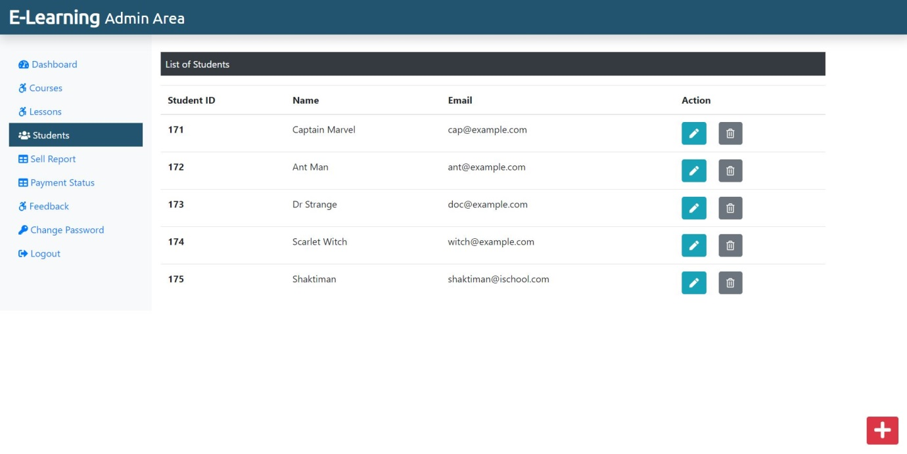
<?php
if(!isset($_SESSION)){
session_start();
}
define('TITLE', 'Students');
define('PAGE', 'students');
include('./adminInclude/header.php');
include('../dbConnection.php');

if(isset($_SESSION['is_admin_login'])){
$adminEmail = $_SESSION['adminLogEmail'];
} else {
echo "<script> location.href='../index.php'; </script>";
}
?>
<div class="col-sm-9 mt-5">
<!--Table-->
<p class=" bg-dark text-white p-2">List of Students</p>
<?php
$sql = "SELECT * FROM student";
$result = $conn->query($sql);
if($result->num_rows > 0){
echo '<table class="table">
<thead>
<tr>
<th scope="col">Student ID</th>
<th scope="col">Name</th>
<th scope="col">Email</th>
<th scope="col">Action</th>
</tr>
</thead>
<tbody>';
while($row = $result->fetch_assoc()){
echo '<tr>';
echo '<th scope="row">'.$row["stu_id"].'</th>';
echo '<td>'. $row["stu_name"].'</td>';
echo '<td>'.$row["stu_email"].'</td>';
echo '<td><form action="editstudent.php" method="POST" class="d-inline"> <input type="hidden" name="id" value='. $row["stu_id"] .'><button type="submit" class="btn btn-info mr-3" name="view" value="View"><i class="fas fa-pen"></i></button></form>
<form action="" method="POST" class="d-inline"><input type="hidden" name="id" value='. $row["stu_id"] .'><button type="submit" class="btn btn-secondary" name="delete" value="Delete"><i class="far fa-trash-alt"></i></button></form></td>
</tr>';
}

echo '</tbody>
</table>';
} else {
echo "0 Result";
}
if(isset($_REQUEST['delete'])){
$sql = "DELETE FROM student WHERE stu_id = {$_REQUEST['id']}";
if($conn->query($sql) === TRUE){
// echo "Record Deleted Successfully";
// below code will refresh the page after deleting the record
echo '<meta http-equiv="refresh" content= "0;URL=?deleted" />';
} else {
echo "Unable to Delete Data";
}
}
?>
</div>
</div> <!-- div Row close from header -->
<div><a class="btn btn-danger box" href="addnewstudent.php"><i class="fas fa-plus fa-2x"></i></a></div>
</div> <!-- div Conatiner-fluid close from header -->
<?php
include('./adminInclude/footer.php');
?>

Addnewstudent.php
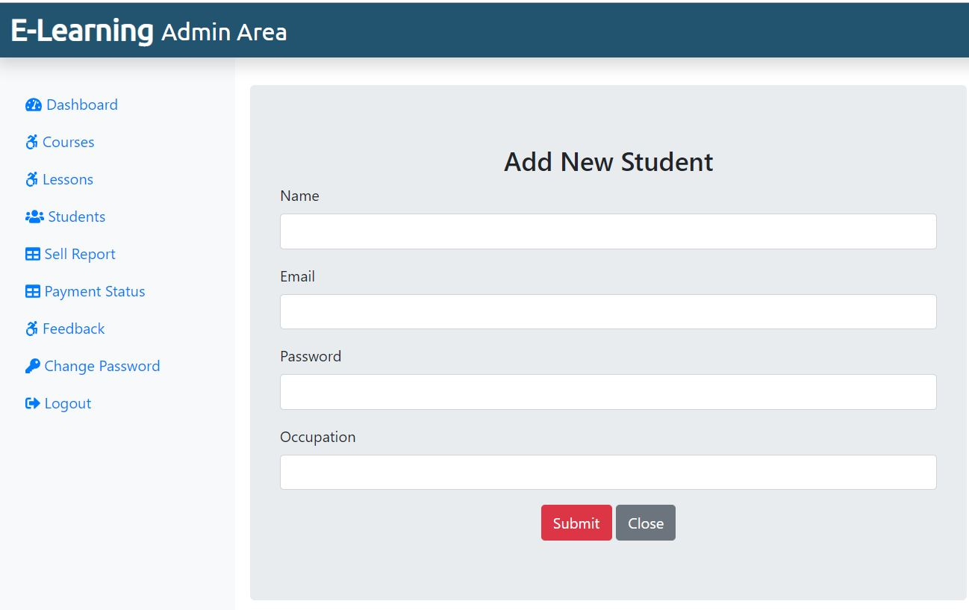
<?php
if(!isset($_SESSION)){
session_start();
}
define('TITLE', 'Add Student');
include('./adminInclude/header.php');
include('../dbConnection.php');

if(isset($_SESSION['is_admin_login'])){
$adminEmail = $_SESSION['adminLogEmail'];
} else {
echo "<script> location.href='../index.php'; </script>";
}
if(isset($_REQUEST['newStuSubmitBtn'])){
// Checking for Empty Fields
if(($_REQUEST['stu_name'] == "") || ($_REQUEST['stu_email'] == "") || ($_REQUEST['stu_pass'] == "") || ($_REQUEST['stu_occ'] == "")){
// msg displayed if required field missing
$msg = '<div class="alert alert-warning col-sm-6 ml-5 mt-2" role="alert"> Fill All Fileds </div>';
} else {
// Assigning User Values to Variable
$stu_name = $_REQUEST['stu_name'];
$stu_email = $_REQUEST['stu_email'];
$stu_pass = $_REQUEST['stu_pass'];
$stu_occ = $_REQUEST['stu_occ'];

$sql = "INSERT INTO student (stu_name, stu_email, stu_pass, stu_occ) VALUES ('$stu_name', '$stu_email', '$stu_pass', '$stu_occ')";
if($conn->query($sql) == TRUE){
// below msg display on form submit success
$msg = '<div class="alert alert-success col-sm-6 ml-5 mt-2" role="alert"> Student Added Successfully </div>';
} else {
// below msg display on form submit failed
$msg = '<div class="alert alert-danger col-sm-6 ml-5 mt-2" role="alert"> Unable to Add Student </div>';
}
}
}
?>
<div class="col-sm-6 mt-5 mx-3 jumbotron">
<h3 class="text-center">Add New Student</h3>
<form action="" method="POST" enctype="multipart/form-data">
<div class="form-group">
<label for="stu_name">Name</label>
<input type="text" class="form-control" id="stu_name" name="stu_name">
</div>
<div class="form-group">
<label for="stu_email">Email</label>
<input type="text" class="form-control" id="stu_email" name="stu_email">
</div>
<div class="form-group">
<label for="stu_pass">Password</label>
<input type="text" class="form-control" id="stu_pass" name="stu_pass">
</div>
<div class="form-group">
<label for="stu_occ">Occupation</label>
<input type="text" class="form-control" id="stu_occ" name="stu_occ">
</div>
<div class="text-center">
<button type="submit" class="btn btn-danger" id="newStuSubmitBtn" name="newStuSubmitBtn">Submit</button>
<a href="students.php" class="btn btn-secondary">Close</a>
</div>
<?php if(isset($msg)) {echo $msg; } ?>
</form>
</div>
</div> <!-- div Row close from header -->
</div> <!-- div Conatiner-fluid close from header -->

<?php
include('./adminInclude/footer.php');
?>

Editstudent.php

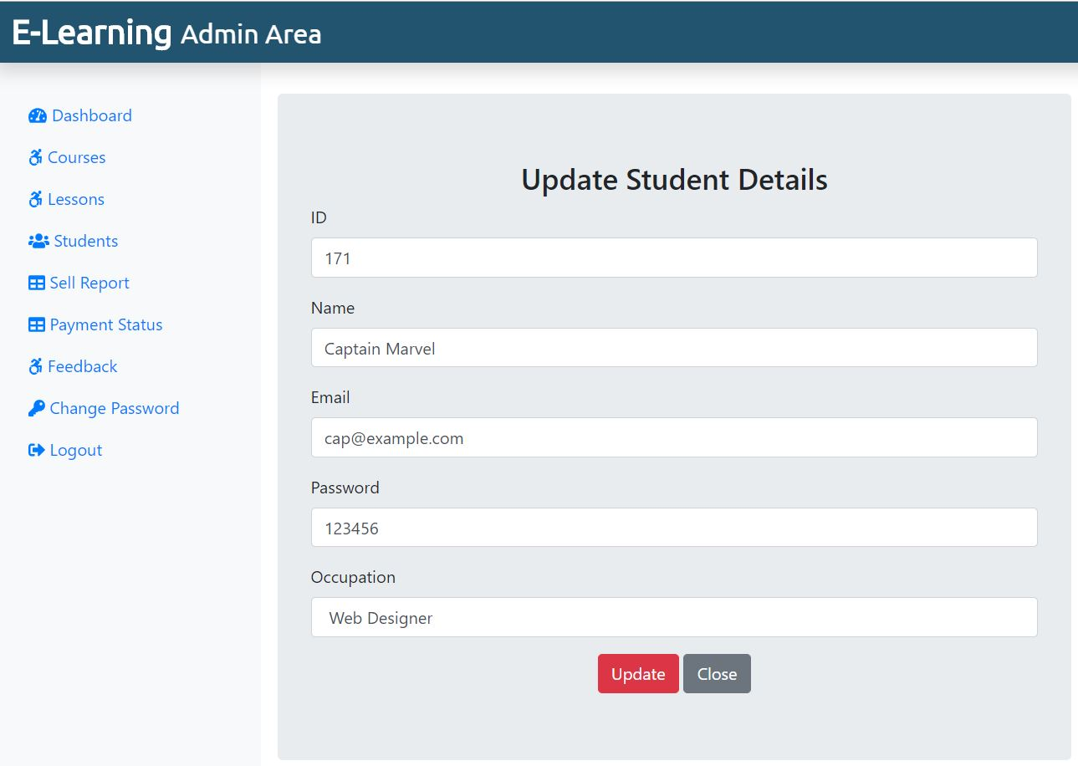

<?php
if(!isset($_SESSION)){
session_start();
}
define('TITLE', 'Edit Course');
include('./adminInclude/header.php');
include('../dbConnection.php');

if(isset($_SESSION['is_admin_login'])){
$adminEmail = $_SESSION['adminLogEmail'];
} else {
echo "<script> location.href='../index.php'; </script>";
}
// Update
if(isset($_REQUEST['requpdate'])){
// Checking for Empty Fields
if(($_REQUEST['stu_id'] == "") || ($_REQUEST['stu_name'] == "") || ($_REQUEST['stu_email'] == "") || ($_REQUEST['stu_pass'] == "") || ($_REQUEST['stu_occ'] == "")){
// msg displayed if required field missing
$msg = '<div class="alert alert-warning col-sm-6 ml-5 mt-2" role="alert"> Fill All Fileds </div>';
} else {
// Assigning User Values to Variable
$sid = $_REQUEST['stu_id'];
$sname = $_REQUEST['stu_name'];
$semail = $_REQUEST['stu_email'];
$spass = $_REQUEST['stu_pass'];
$socc = $_REQUEST['stu_occ'];

$sql = "UPDATE student SET stu_id = '$sid', stu_name = '$sname', stu_email = '$semail', stu_pass='$spass', stu_occ='$socc' WHERE stu_id = '$sid'";
if($conn->query($sql) == TRUE){
// below msg display on form submit success
$msg = '<div class="alert alert-success col-sm-6 ml-5 mt-2" role="alert"> Updated Successfully </div>';
} else {
// below msg display on form submit failed
$msg = '<div class="alert alert-danger col-sm-6 ml-5 mt-2" role="alert"> Unable to Update </div>';
}
}
}
?>
<div class="col-sm-6 mt-5 mx-3 jumbotron">
<h3 class="text-center">Update Student Details</h3>
<?php
if(isset($_REQUEST['view'])){
$sql = "SELECT * FROM student WHERE stu_id = {$_REQUEST['id']}";
$result = $conn->query($sql);
$row = $result->fetch_assoc();
}
?>
<form action="" method="POST" enctype="multipart/form-data">
<div class="form-group">
<label for="stu_id">ID</label>
<input type="text" class="form-control" id="stu_id" name="stu_id" value="<?php if(isset($row['stu_id'])) {echo $row['stu_id']; }?>"readonly>
</div>
<div class="form-group">
<label for="stu_name">Name</label>
<input type="text" class="form-control" id="stu_name" name="stu_name" value="<?php if(isset($row['stu_name'])) {echo $row['stu_name']; }?>">
</div>

<div class="form-group">
<label for="stu_email">Email</label>
<input type="text" class="form-control" id="stu_email" name="stu_email" value="<?php if(isset($row['stu_email'])) {echo $row['stu_email']; }?>">
</div>

<div class="form-group">
<label for="stu_pass">Password</label>
<input type="text" class="form-control" id="stu_pass" name="stu_pass" value="<?php if(isset($row['stu_pass'])) {echo $row['stu_pass']; }?>">
</div>
<div class="form-group">
<label for="stu_occ">Occupation</label>
<input type="text" class="form-control" id="stu_occ" name="stu_occ" value="<?php if(isset($row['stu_occ'])) {echo $row['stu_occ']; }?>">
</div>

<div class="text-center">

<button type="submit" class="btn btn-danger" id="requpdate" name="requpdate">Update</button>

<a href="students.php" class="btn btn-secondary">Close</a>
</div>

<?php if(isset($msg)) {echo $msg; } ?>
</form>

</div>

</div> <!-- div Row close from header -->
</div> <!-- div Conatiner-fluid close from header -->

<?php
include('./adminInclude/footer.php');
?>

Sellreport.php

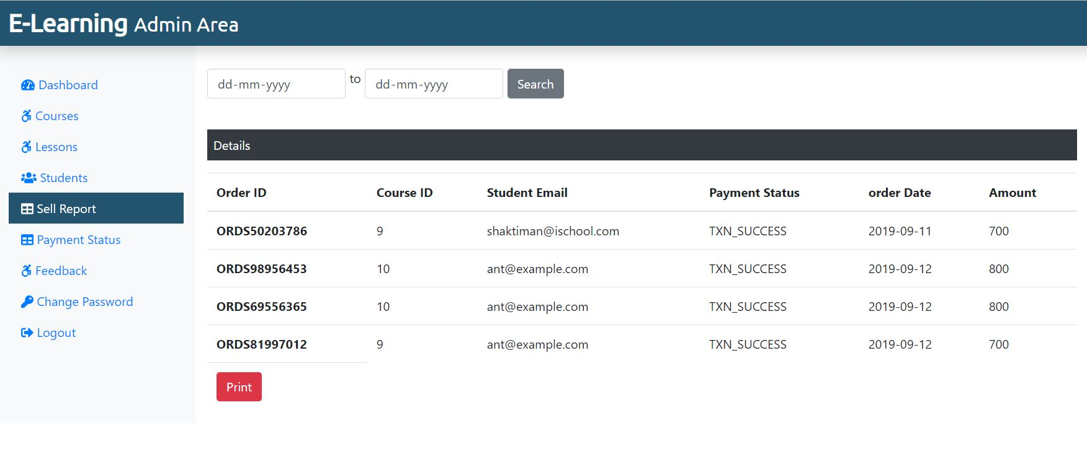
<?php
if(!isset($_SESSION)){
session_start();
}
define('TITLE', 'Sell Report');

define('PAGE', 'sellreport');

include('./adminInclude/header.php');

include('../dbConnection.php');

if(isset($_SESSION['is_admin_login'])){
$adminEmail = $_SESSION['adminLogEmail'];
} else {
echo "<script> location.href='../index.php'; </script>";
}
?>

<div class="col-sm-9 mt-5">

<form action="" method="POST" class="d-print-none">

<div class="form-row">
<div class="form-group col-md-2">
<input type="date" class="form-control" id="startdate" name="startdate">
</div> <span> to </span>
<div class="form-group col-md-2">
<input type="date" class="form-control" id="enddate" name="enddate">
</div>

<div class="form-group">
<input type="submit" class="btn btn-secondary" name="searchsubmit" value="Search">
</div>
</div>
</form>

<?php
if(isset($_REQUEST['searchsubmit'])){
$startdate = $_REQUEST['startdate'];
$enddate = $_REQUEST['enddate'];
// $sql = "SELECT * FROM courseorder WHERE order_date BETWEEN '2018-10-11' AND '2018-10-13'";
$sql = "SELECT * FROM courseorder WHERE order_date BETWEEN '$startdate' AND '$enddate'";
$result = $conn->query($sql);
if($result->num_rows > 0){
echo '
<p class=" bg-dark text-white p-2 mt-4">Details</p>

<table class="table">
<thead>
<tr>
<th scope="col">Order ID</th>
<th scope="col">Course ID</th>
<th scope="col">Student Email</th>
<th scope="col">Payment Status</th>
<th scope="col">order Date</th>
<th scope="col">Amount</th>
</tr>
</thead>

<tbody>';
while($row = $result->fetch_assoc()){
echo '<tr>
<th scope="row">'.$row["order_id"].'</th>
<td>'.$row["course_id"].'</td>
<td>'.$row["stu_email"].'</td>
<td>'.$row["status"].'</td>
<td>'.$row["order_date"].'</td>
<td>'.$row["amount"].'</td>
</tr>';
}
echo '<tr>
<td><form class="d-print-none"><input class="btn btn-danger" type="submit" value="Print" onClick="window.print()"></form></td>
</tr></tbody>
</table>';
} else {
echo "<div class='alert alert-warning col-sm-6 ml-5 mt-2' role='alert'> No Records Found ! </div>";
}
}
?>
</div>
</div>
</div>

</div> <!-- div Row close from header -->
</div> <!-- div Conatiner-fluid close from header -->
<?php
include('./adminInclude/footer.php');
?>

adminPaymentstatus.php

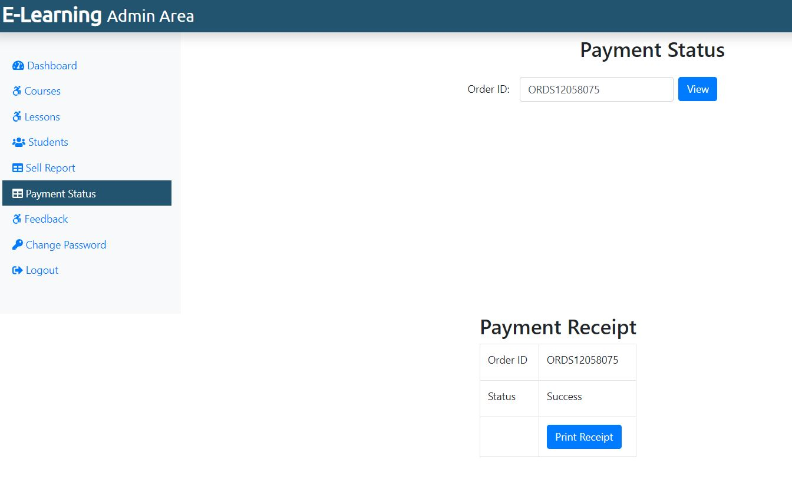

<?php
define('TITLE', 'Payment Status');
define('PAGE', 'paymentstatus');
include('../dbConnection.php');
include('./adminInclude/header.php');
$ORDER_ID = "";

if (isset($_POST["ORDER_ID"]) && $_POST["ORDER_ID"] != "") {
$ORDER_ID = $_POST["ORDER_ID"];
}

?>
<div class="container">
<h2 class="text-center my-4">Payment Status </h2>
<form method="post" action="">
<div class="form-group row">
<label class="offset-sm-3 col-form-label">Order ID: </label>
<div>
<input class="form-control mx-3" id="ORDER_ID" tabindex="1" maxlength="20" size="20" name="ORDER_ID" autocomplete="off" value="<?php echo $ORDER_ID ?>">
</div>
<div>
<input class="btn btn-primary mx-4" value="View" type="submit" onclick="">
</div>
</div>
</form>
</div>
<div class="container">
<?php
if (isset($_POST['ORDER_ID']))
{
$sql = "SELECT order_id FROM courseorder";
$result = $conn->query($sql);
while($row = $result->fetch_assoc()){
if($_POST["ORDER_ID"] == $row["order_id"]){ ?>
<div class="row justify-content-center">
<div class="col-auto">
<h2 class="text-center">Payment Receipt</h2>
<table class="table table-bordered">
<tbody>
<tr >
<td><label>Order ID</label></td>
<td><?php if (isset($row["order_id"])) echo $row["order_id"] ?></td>
</tr>
<tr >
<td><label>Status</label></td>
<td>Success</td>
</tr>
<tr>
<td></td>
<td><button class="btn btn-primary" onclick="javascript:window.print();">Print Receipt</button></td>
</tr>
</tbody>
</table>
</div>
</div>
<?php
} } } ?>

</div>
</div>

</div>
</div> <!-- div Row close from header -->
</div> <!-- div Conatiner-fluid close from header -->
<?php
include('./adminInclude/footer.php');
?>

Feedback.php

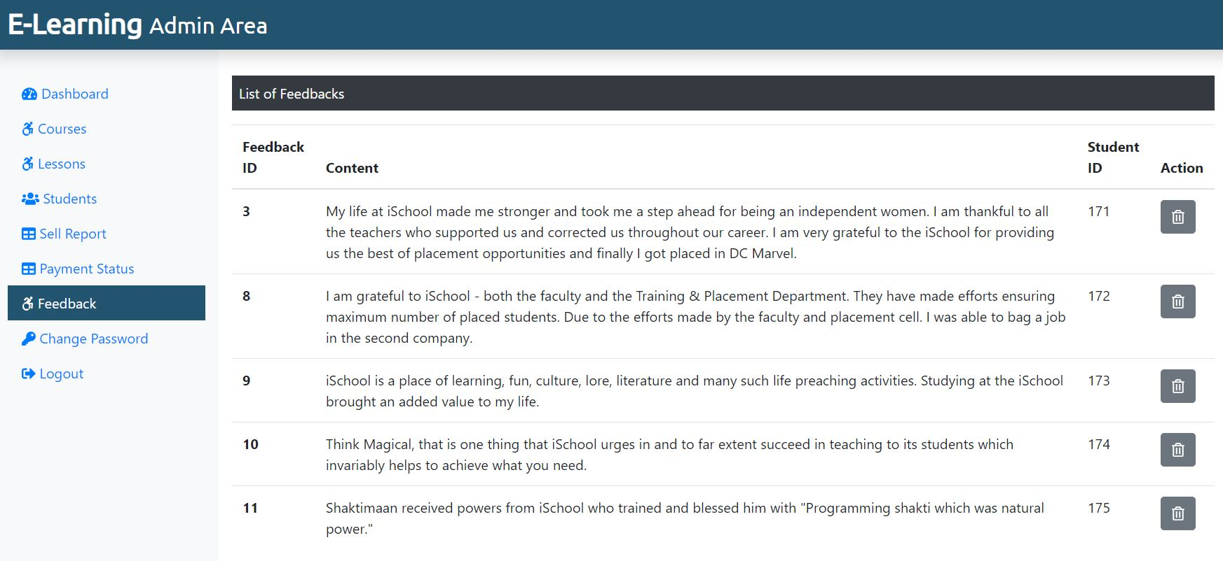

<?php
if(!isset($_SESSION)){
session_start();
}
define('TITLE', 'Feedback');
define('PAGE', 'feedback');
include('./adminInclude/header.php');
include('../dbConnection.php');

if(isset($_SESSION['is_admin_login'])){
$adminEmail = $_SESSION['adminLogEmail'];
} else {
echo "<script> location.href='../index.php'; </script>";
}
?>
<div class="col-sm-9 mt-5">
<!--Table-->
<p class=" bg-dark text-white p-2">List of Feedbacks</p>
<?php
$sql = "SELECT * FROM feedback";
$result = $conn->query($sql);
if($result->num_rows > 0){
echo '<table class="table">
<thead>
<tr>
<th scope="col">Feedback ID</th>
<th scope="col">Content</th>
<th scope="col">Student ID</th>
<th scope="col">Action</th>
</tr>
</thead>
<tbody>';
while($row = $result->fetch_assoc()){
echo '<tr>';
echo '<th scope="row">'.$row["f_id"].'</th>';
echo '<td>'. $row["f_content"].'</td>';
echo '<td>'.$row["stu_id"].'</td>';
echo '<td><form action="" method="POST" class="d-inline"><input type="hidden" name="id" value='. $row["f_id"] .'><button type="submit" class="btn btn-secondary" name="delete" value="Delete"><i class="far fa-trash-alt"></i></button></form></td>
</tr>';
}

echo '</tbody>
</table>';
} else {
echo "0 Result";
}
if(isset($_REQUEST['delete'])){
$sql = "DELETE FROM feedback WHERE f_id = {$_REQUEST['id']}";
if($conn->query($sql) === TRUE){
// echo "Record Deleted Successfully";
// below code will refresh the page after deleting the record
echo '<meta http-equiv="refresh" content= "0;URL=?deleted" />';
} else {
echo "Unable to Delete Data";
}
}
?>
</div>
</div> <!-- div Row close from header -->
</div> <!-- div Conatiner-fluid close from header -->
<?php
include('./adminInclude/footer.php');
?>

Adminchangepass.php
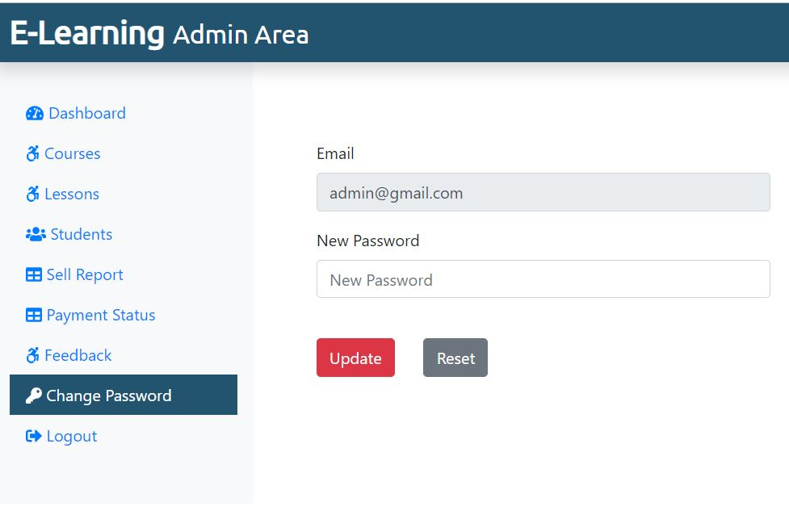
<?php

if(!isset($_SESSION)){
session_start();

}
define('TITLE', 'Change Password');

define('PAGE', 'changepass');

include('./adminInclude/header.php');

include('../dbConnection.php');

if(isset($_SESSION['is_admin_login'])){

$adminEmail = $_SESSION['adminLogEmail'];

} else {
echo "<script> location.href='../index.php'; </script>";
}

$adminEmail = $_SESSION['adminLogEmail'];
if(isset($_REQUEST['adminPassUpdatebtn'])){
if(($_REQUEST['adminPass'] == "")){
// msg displayed if required field missing
$passmsg = '<div class="alert alert-warning col-sm-6 ml-5 mt-2" role="alert"> Fill All Fileds </div>';
} else {
$sql = "SELECT * FROM admin WHERE admin_email='$adminEmail'";

$result = $conn->query($sql);
if($result->num_rows == 1){
$adminPass = $_REQUEST['adminPass'];
$sql = "UPDATE admin SET admin_pass = '$adminPass' WHERE admin_email = '$adminEmail'";
if($conn->query($sql) == TRUE){
// below msg display on form submit success
$passmsg = '<div class="alert alert-success col-sm-6 ml-5 mt-2" role="alert"> Updated Successfully </div>';
} else {
// below msg display on form submit failed
$passmsg = '<div class="alert alert-danger col-sm-6 ml-5 mt-2" role="alert"> Unable to Update </div>';
}
}
}
}
?>

<div class="col-sm-9 mt-5">
<div class="row">
<div class="col-sm-6">
<form class="mt-5 mx-5">
<div class="form-group">
<label for="inputEmail">Email</label>
<input type="email" class="form-control" id="inputEmail" value=" <?php echo $adminEmail ?>" readonly>
</div>
<div class="form-group">
<label for="inputnewpassword">New Password</label>
<input type="text" class="form-control" id="inputnewpassword" placeholder="New Password" name="adminPass">
</div>

<button type="submit" class="btn btn-danger mr-4 mt-4" name="adminPassUpdatebtn">Update</button>
<button type="reset" class="btn btn-secondary mt-4">Reset</button>

<?php if(isset($passmsg)) {echo $passmsg; } ?>

</form>
</div>
</div>
</div>

</div> <!-- div Row close from header -->

</div> <!-- div Conatiner-fluid close from header -->

<?php
include('./adminInclude/footer.php');
?>

Watchcourse.php
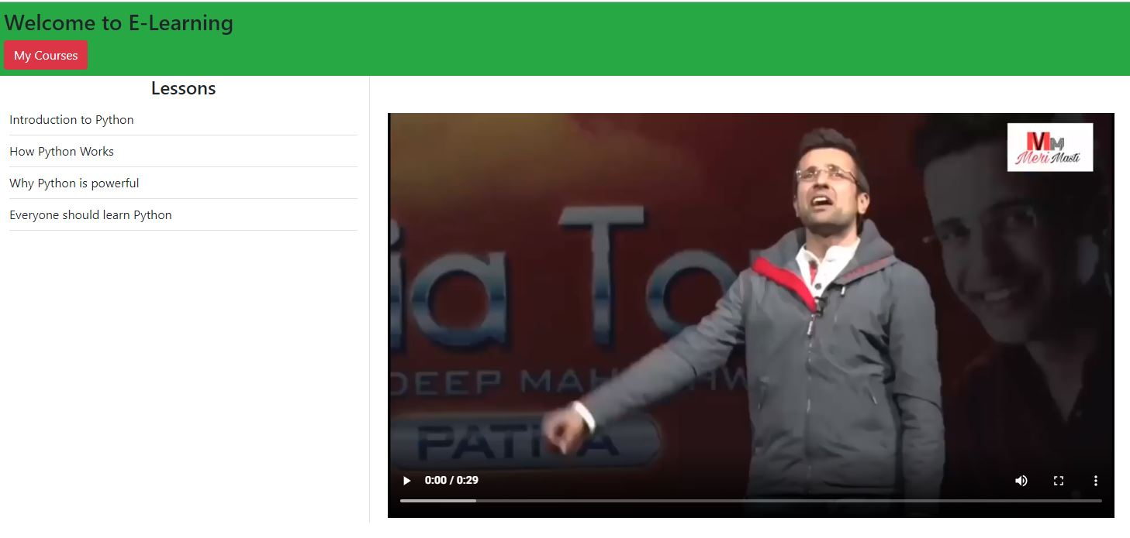
<?php
if(!isset($_SESSION)){
session_start();
}
include('../dbConnection.php');

if(isset($_SESSION['is_login'])){
$stuEmail = $_SESSION['stuLogEmail'];
} else {
echo "<script> location.href='../index.php'; </script>";
}
?>

<!DOCTYPE html>
<html lang="en">
<head>
<meta charset="UTF-8">
<meta name="viewport" content="width=device-width, initial-scale=1.0">
<meta http-equiv="X-UA-Compatible" content="ie=edge">
<title>Watch Course</title>

<!-- Bootstrap CSS -->
<link rel="stylesheet" href="../css/bootstrap.min.css">

<!-- Font Awesome CSS -->
<link rel="stylesheet" href="../css/all.min.css">

<!-- Google Font -->
<link href="https://fonts.googleapis.com/css?family=Ubuntu" rel="stylesheet">

<!-- Custom CSS -->
<link rel="stylesheet" href="../css/stustyle.css">
</head>

<body>

<div class="container-fluid bg-success p-2" >
<h3>Welcome to E-Learning</h3>

<a class="btn btn-danger" href="./myCourse.php">My Courses</a>
</div>

<div class="container-fluid">
<div class="row">
<div class="col-sm-3 border-right">
<h4 class="text-center">Lessons</h4>
<ul id="playlist" class="nav flex-column">

<?php
if(isset($_GET['course_id'])){
$course_id = $_GET['course_id'];
$sql = "SELECT * FROM lesson WHERE course_id = '$course_id'";
$result = $conn->query($sql);
if($result->num_rows > 0){
while($row = $result->fetch_assoc()){
echo '<li class="nav-item border-bottom py-2" movieurl='.$row['lesson_link'].' style="cursor: pointer;">'. $row['lesson_name'] .'</li>';
}
}
}
?>
</ul>
</div>
<div class="col-sm-8">
<video id="videoarea" src="" class="mt-5 w-75 ml-2" controls>
</video>
</div>
</div>
</div>

<!-- Jquery and Boostrap JavaScript -->
<script type="text/javascript" src="../js/jquery.min.js"></script>
<script type="text/javascript" src="../js/popper.min.js"></script>

<script type="text/javascript" src="../js/bootstrap.min.js"></script>

<!-- Font Awesome JS -->
<script type="text/javascript" src="../js/all.min.js"></script>

<!-- Ajax Call JavaScript -->
<!-- <script type="text/javascript" src="..js/ajaxrequest.js"></script> -->

<!-- Custom JavaScript -->
<script type="text/javascript" src="../js/custom.js"></script>
</body>
</html>

- Testing

Software testing is a process used to identify the correctness, completeness and quality of developed computer software. It includes a set of activities conducted with the intent of finding errors in software so that it could be corrected before the product is released to the end users. In other word software testing is an activity to check that the software system is defect free.
Software testing is primarily a broad process that is composed of several interlinked processes. The primary objective of software testing is to measure software health along with its completeness in terms of core requirements. Software testing involves examining and checking software through different testing processes.
The objectives of these processes can include:
- Completeness - Verifying software completeness in regards to functional/business requirements
- Errors Free - Identifying technical bugs/errors and ensuring the software is error-free
- Stability - Assessing usability, performance, security, localization, compatibility and installation

This phase determine the error in the project. If there is any error then it must be removed before delivery of the project.

7.1 Type of Testing

For determining errors various types of test action are performed: -
Unit Testing: - Unit testing focuses verification effort on the smallest unit of software design – the module. Using the detail design description as a guide, important control paths are tested to uncover errors within the boundary of the module. The relative complexity of tests and the errors detected as a result is limited by the constrained scope established for unit testing. The unit test is always white box oriented, and the step can be conducted in parallel for multiple modules.
Unit testing is normally considered an adjunct to the coding step. After source level code has been developed, reviewed, and verified for correct syntax, unit test case design begins.

Integration Testing - A level of the software testing process where individual units are combined and tested as a group. The purpose of this level of testing is to expose faults in the interaction between integrated units.

System Testing: - Software is only one element of a larger computer based system. Ultimately, software is incorporated with other system elements (e.g. new hardware, information), and a series of system integration and validation tests are conducted. Steps taken during software design and testing can greatly improve the probability of successful software integration in the larger system.
A classics system testing problem is “finger pointing”. This occurs when a defect is uncovered, and one system element developer blames another for the problem. The software engineer should anticipate potential interfacing problems and design error handling paths that test all information coming from other elements of the system, conduct a series of tests that simulate bad data or other potential errors at the software interface, record the results or tests to use as “evidence” if finger pointing does occur, participate in the planning and design of system test to ensure that software is adequately tested.

There are many types of system tests that are worthwhile for software-based systems:-

Usability Testing - Usability Testing is a type of testing done from an end-user’s perspective to determine if the system is easily usable.

Functionality Testing - Tests all functionalities of the software against the requirement.

Performance Testing – Performance testing is designed to test the run-time performance of software within the context of an integrated system.

Security Testing – Security testing attempts to verify that protection mechanisms built into a system will protect it from improper penetration.

Stress Tests – Stress tests are designed to confront programs with abnormal situations.

7.2 Use Case

A use case diagram is essentially a picture showing system behavior along with the key actors that interact with the system. The use case represents complete functionality. Use case diagram can be imagined as a black box where only the input, output, and the function of the black box are known. Use Case elements are used to make test cases when performing the testing. The use case should contain all system activities that have significance to the users. A use case can be thought of as a collection of possible scenarios related to a particular goal, indeed. Use cases can be employed during several stages of software development, such as planning system requirements, validating design and testing software.
Use case Diagram Objects
Use case diagrams mostly consist of 3 objects: -
Actor - Actor is a use case diagram is any entity that performs a role in one given system. This could be a person, organization or an external system.
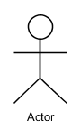

Use Case - A Use case represents a function or an action within the system. its drawn as an oval and named with the function.
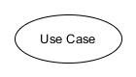

System - System is used to define the scope of the use case and drawn as rectangle.
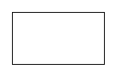

There are two functions: -
Include – This represents required. Symbol of this function is dashed arrow and arrow is labeled with the keyword <<include>>

Extend – This represents optional and it is also shown with dashed arrow the arrow is labeled with the keyword <<extend>>

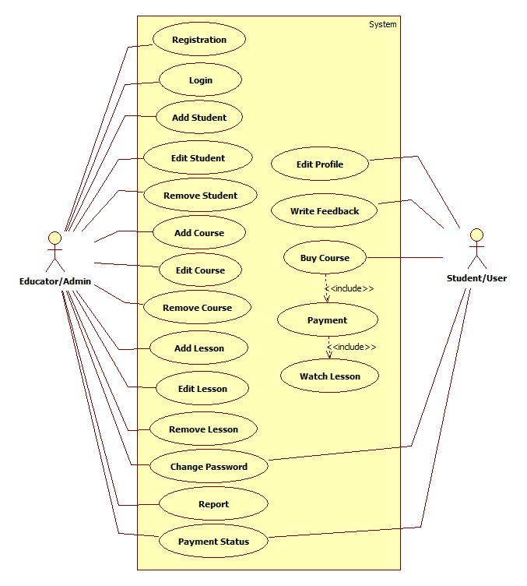

Use Case

7.3 Test Case
A test case is a set of conditions or variables under which a tester will determine whether an application, software system or one of its features is working as it was originally established for it to do.

Login:
Test Case ID | Test Scenario | Test Case | Pre-Condition | Test Steps | Test Data | Expected Result | Actual Result | Status  Pass/Fail
TC_Login_1 | Verify Login | Enter Valid username and valid password | Need a valid username and password to do login | 1. Enter username  2. Enter Password  3. Click Login | Valid username  Valid password | Successful login, Main screen of application should displayed | Successful login, Main screen of application displayed | Pass
TC_Login_2 | Verify Login | Enter Valid username and invalid password | Need a valid username and password to do login | 1. Enter username  2. Enter Password  3. Click Login | Valid username  Invalid Password | No Matched Username/ Password | No Matched Username/ Password | Pass
TC_Login_3 | Verify Login | Enter Invalid username and valid password | Need a valid username and password to do login | 1. Enter username  2. Enter Password  3. Click Login | Invalid username  Valid Password | No Matched Username/ Password | No Matched Username/ Password | Pass
TC_Login_4 | Verify Login | Enter Invalid username and invalid password | Need a valid username and password to do login | 1. Enter username  2. Enter Password  3. Click Login | Invalid username  Invalid Password | No Matched Username/ Password | No Matched Username/ Password | Pass

User/Student Registration
Test Case ID | Test Scenario | Test Case | Pre-Condition | Test Steps | Test Data | Expected Result | Actual Result | Status  Pass/Fail
TC_SREG_1 | Verify User Registration Detail | Enter valid name, email, new password | Need valid Data to be entered | 1. Enter name  2. Enter email  3. Enter Password  4. Click Sign up | Valid name, valid email, valid password | Successful, User Added Successfully | Successful, User Added Successfully | Pass
TC_SREG_2 | Verify Staff Registration Detail | Enter name, already registered email, new password | Need Data to be entered | 1. Enter name  2. Enter Email  3. Enter Password  4. Click Sign up | Valid name, already registered email, valid password | Email ID Already Registered | Email ID Already Registered | Pass
TC_SREG_3 | Verify Staff Registration Detail | Entering Nothing, Required Fields are blank | - | Click Sign up | Nothing to enter Required fields are blank | Fill required field | Fill required field | Pass
Add Course
Test Case ID | Test Scenario | Test Case | Pre-Condition | Test Steps | Test Data | Expected Result | Actual Result | Status  Pass/Fail
TC_Course_1 | Verify Course Detail | Enter Valid and correct data | Need valid text and number Data to be entered | 1. Enter Valid Data in appropriate fields  2. Click Submit | Valid Text and Number Data | Successful, Course Added Successfully | Successful, Course Added Successfully | Pass
TC_Course_2 | Verify Course Detail | Enter invalid and incorrect data | Need text and number Data to be entered | Enter invalid Data in fields | Invalid Text and Number Data | Enter Valid Data | Enter Valid Data | Pass
TC_Course_3 | Verify Course Detail | Entering Nothing, Required Fields are blank | - | Click Submit | Nothing to enter Required fields are blank | Fill required field | Fill required field | Pass

- Implementation
Our dedication to our Clients goes well beyond the deployment of our Application. We are committed to providing our Client with a positive experience that starts with a successful implementation.
Implementation is the stage in the project where the theoretical design is turned into a working system. The implementation phase constructs, installs and operates the new system. The most stage is achieving a new successful system is that it will work efficiently and effectively.
Security and integrity of database are very important for any software system because databases are the backbone of the system. Security need to be implanted at every level of the system so that only authorized user can access the system for updation and other significance process.

- Cost Estimation of Project

9.1 Domain and Hosting cost

We can give developed system a name by purchasing a domain so the world can access it easily as well as we need to host our files. Hosting cost is most important part to host the website. To host a website we need a web server. It is not feasible for any organization to setup a web server for hosting a website. So it recommended hosting the website in a data centre. The facility of the data centre is very good because they can provide the replication of the website for reducing the traffic on a single server. The hosting cost of the website is as follows (for one Year):
Description | Cost Per Year (Rs.)
Domain Name Registration | 1200
Web Space 20 GB, 100 GB Transfer | 1800
Total | 3000

9.2 Hardware cost
To update the website and for maintaining the database, the organization need a computer system, which can work as a local server from here only the website can be updated, so the hardware cost for this project will be:

Description | Cost (Rs.)
Computer | 25000
Modem | 2000
UPS | 4000
Total | 31000

9.3 Software cost
To maintain the websites:

Description | Cost (Rs.)
PHP | Free of Cost
MySQL | Free of cost
Apache | Free of cost
Webserver | Free of cost
Total | Free

9.4 Development cost /Operating cost
The operating cost includes the day to day cost incurred in running the website this will include the salary paid to the staff appointed for maintaining the website. The website the customer will find the website very useful as they can submit their complains online and can et their response on click.

Description | Cost (Rs.)
Electric charge for 100 unit | 500
Salary of two staff (7000/Each ) | 14000
Total | 14500

TOTAL
This is the total cost of the development of the system.

Description | Cost (Rs.)
Domain and Hosting Cost | 3000
Hardware Cost | 31000
Software Cost | 0
Development Cost/Operating Cost | 14500
Total | 48500

- Limitation

- Only one tutor can access at a time
- It’s not SEO friendly
- Risk unauthorized accessibility
- Support is good in modern web browsers but not in legacy ones

- Future Scope

- More than one tutor can be added
- Interaction between Student and Tutor can be improved by introducing Discussion forum
- Quiz Facility may enhance this application’s market value
- Live Class can be added

- Conclusion
The iSchool E-Learning Maintenance Managment System has been computed successfully and was also tested successfully by taking "Test Cases". It is user friendly, and has required options, which can be utilized by the user to perform the desired operations.
The Software is developed using HTML, CSS, JS as front end and PHP, MySql as back end in windows environment.
The goals that are achieved by the software are:
- Simplification of the operations
- Less processing time and getting required information
- User friendly
- Portable and flexible for further enhancement

Bibliography
The following reference has been used to develop the project “iSchool” :-
Books: -
- IGNOU Blocks of Systems Analysis and Design
- IGNOU Blocks of Introduction to Software Engineering
- The Complete Reference PHP
- Head First SQL: Your Brain on SQL by Lynn Beighley
Web Source: -
- www.google.co.in
- www.wikipedia.org
- www.php.net
- www.stackoverflow.com
- www.getbootstrap.com
- www.fontawesome.com

